CHAPTER 1
INTRODUCTION
The rapid development of information technology has made it easier for people to access information from different parts of the world. In particular, the Internet has become an important source of information for people who want to learn about countries, cultures, lifestyles, food, and social practices. Asia is one of the world's most culturally diverse regions. Different Asian countries have their own traditions, customs, lifestyles, social behaviors, food cultures, and etiquette. Because of these differences, people who travel to or interact with individuals from other countries may need to understand local customs and appropriate social behavior. The Asia Explorer System was developed as a web-based platform to organize and present this type of information in a convenient manner. Instead of requiring users to search through many different sources, the system provides an integrated environment where users can explore country-related information through a single interface. The project proposal also identifies the importance of providing cultural and etiquette information, structured data, interactive user interaction, and a convenient web interface. However, the final system documentation is based primarily on the actual implementation contained in the Asia Explorer System project. The system is therefore designed to serve as an accessible information and exploration platform for users interested in Asian countries, culture, lifestyle, etiquette, and food.
  - Problem Statement
People who want to learn about different Asian countries often need to search through multiple websites and information sources. Information related to culture, etiquette, lifestyle, and food may be distributed across different pages and platforms.
This creates several difficulties. First, users may spend considerable time searching for specific information. Second, information can be presented in different formats, making it difficult to compare or understand country-specific practices. Third, users who are unfamiliar with a country's customs may unintentionally behave inappropriately because they do not know local etiquette or cultural expectations. Another problem is that general search engines do not necessarily organize information specifically according to the user's cultural exploration needs. Users may have to perform several searches to find information about greetings, traditional dress, taboos, social behavior, and food. Therefore, the Asia Explorer System aims to provide an organized and interactive platform where users can explore relevant information about Asian countries through a unified web-based system.
1.2 Objectives
- To develop a web-based platform for exploring information about Asian countries.
- To provide organized cultural and lifestyle information.
- To provide information about social etiquette and appropriate behavior.
- To present country-specific greetings and cultural practices.
- To provide information about traditional dress and cultural taboos.
- To provide useful information about food and dining culture.
- To allow users to interact with the system through an easy-to-use interface.
- To organize information using a structured data format.
- To provide a system that can be extended with additional countries and information in the future.
1.3 Scope of the System (48 Asian Countries)
The Asia Explorer System focuses on providing users with organized information about Asian countries, related cultural topics and modified images. The scope of the system includes the following major areas: The system provides information that helps users understand the general culture and characteristics associated with Asian countries. Users can explore information about greetings and appropriate social etiquette. It can provide information concerning appropriate clothing and dress-related cultural practices. Users can learn about behaviors, actions, or practices that may be considered inappropriate within particular cultural contexts. It presents useful guidance about behaviors that are recommended or should be avoided. It can provide information related to local food and dining practices. It can provide an interface through which users can interact with the available information. It can develop an image processing system that provides various image editing and transformation features, including background removal, pencil sketch and watercolor effects, Ghibli-style image processing, background replacement, and face swapping.

1.4 Team Member Activity and Responsibility
Table 1.1 Team Member Activity and Responsibility
No | Name | Responsibility
1 | Ma Hay Mar Zaw | Requirement Gathering, Documentation
2 | Ma Win Htet Htet Aung | Documentation, Testing
3 | Ma Ei Thazin Aung | Image Processing/ AI Features
4 | Ma Su May Phoo Pan | Data Collection, Planning
5 | Ma Su Mon Htwe | Planning and UI-Design, Coding
6 | Ma May Chue Khin | Planning and UI-Design, Coding
7 | Ma Nandar Aung | Requirement Gathering, Documentation

1.5 Planning Phase
The development process was planned according to the major activities required to produce the system. When we implemented the project, we followed the plan outline in Figure 1.1. This project was carried out approximately four weeks form 22th July 2026 to 27th August 2026.
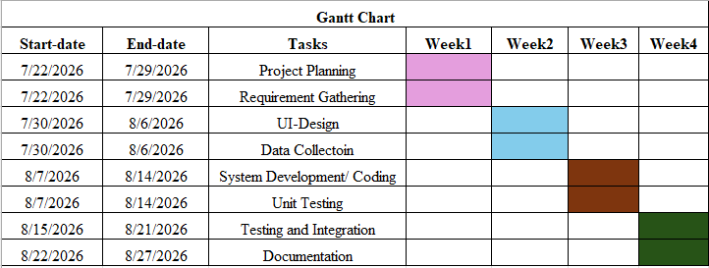
Figure 1.1 Work Breakdown Structure
In the first week (7/22/2026 to 7/29/2026), we focused on project planning and requirement gathering for the project.
In the second week (7/30/2026 to 8/6/2026), we worked on the UI design and carried out the data collection process.
In the third week (8/7/2026 to 8/14/2026), we started system development and coding, along with unit testing.
In the fourth week (8/15/2026 to 8/27/2026), we performed testing and system integration, and completed the project documentation.

CHAPTER 2
REQUIREMENT ANALYSIS
This chapter provides a detailed overview of the system requirements necessary for designing and developing the Asia Explorer System. Requirement analysis plays a fundamental role in defining the system's core capabilities, operational boundaries, and performance expectations to ensure it meets both user needs and system integrity standards.
The chapter begins with the Functional Requirements, outlining the specific features and capabilities provided to the user, including cultural exploration, image processing, and astrology services. It then details the Non-Functional Requirements, which specify the quality attributes, usability standards, performance constraints, and architectural scalability of the system. Furthermore, it presents the Use Cases and their corresponding operational descriptions to illustrate how primary actors interact with different system modules. Finally, the chapter defines the Business Rules that enforce data validation, access limits, and execution logic across all system components.
2.1 Functional Requirements
The Functional Requirements of the Asia Explorer System are to systematically collect and display information about Asian countries, cultural practices, greetings and social etiquette, traditional dress guidelines, Dos and Don'ts, and food and dining customs for users to explore, as well as to perform image processing on beautiful photos of Asian people and landscapes and allow horoscope queries specifically for Myanmar and China.
2.2 Non-Functional Requirements
The Non-Functional Requirements of the Asia Explorer System focus on the system's quality standards and constraints, aiming to provide a highly usable and compatible interface (Usability & Compatibility) that functions seamlessly on both desktop and mobile browsers, allowing users with no technical background to easily explore information and submit queries. Additionally, the system must deliver efficient performance (Performance) by processing normal queries and returning responses in less than 500 milliseconds. To ensure reliability (Reliability), the system must remain stable and operate correctly without crashing—even if some data is missing—by utilizing an appropriate fallback mechanism. Lastly, the system is built to meet high maintainability and extensibility (Maintainability & Extensibility) standards through a modular architecture and systematically structured JSON data, allowing new countries and cultural information to be easily integrated and updated without affecting unrelated parts of the system.
2.3 Use Cases
Use Case Description for Cultural Knowledge Base Module
The use case diagram outlines the primary interactions between the primary actor (User) and the Cultural Knowledge Base Module within the system. The user directly triggers four main functional categories: View Culture & Etiquette, View Festivals & Traditions, View Foods, and View Landmarks. Each of these core features maintains a mandatory «include» relationship with Select Country on Asia Map, enforcing that a target nation must be chosen on the map before displaying the corresponding localized regional details. Furthermore, an optional «extend» relationship connects Ask Fortune to Select Country on Asia Map, enabling conditional execution of the specialized astrology engine specifically when eligible countries (e.g., Myanmar or China) are selected.
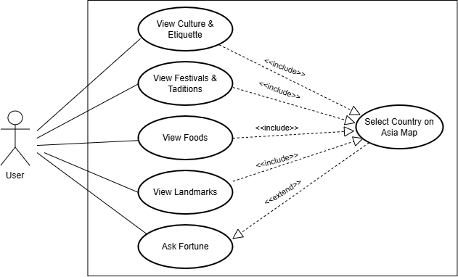
Figure2.1 Use Case for Cultural Knowledge Base Module
Use Case Description for Image Processing Engine Module
The use case diagram illustrates the operational flow of the 6-Stage Image Processing Engine Module. The User interacts with the system by triggering the View Process Buttons and subsequently selecting a specific processing algorithm. The image processing features are broadly categorized into two structural patterns based on execution requirements: Single Image Processing (which includes Remove Background, Pencil Sketch, Water Color, and Ghibli Style requiring 1 image upload) and Dual Image Processing (which includes Change Background and Face Swap requiring 2 image uploads). For the Change Background operation, an «include» relationship mandates the execution of Perform Edit and Save prior to final output generation. Once processing completes across any selected algorithm, all workflows converge into an «include» relationship with Download Result Image, enabling the user to save the final transformed output file.
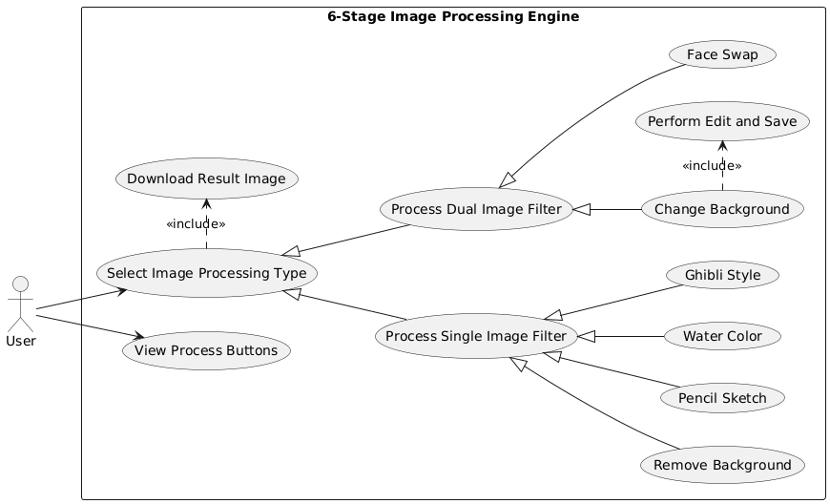
Figure2.2 Use Case Description for Image Processing Engine Module
2.4 Business Rules
The Asia Explorer System operates under a set of defined business rules to ensure system integrity, resource control, data accuracy, and reliable user interactions across all modules.
- Module 1: Cultural Knowledge Base
  - Rule 1.1 (Country Pre-selection): Regional information (Culture, Etiquette, Festivals, Foods, Landmarks) cannot be accessed without first selecting a valid country from the interactive Asia Map.
  - Rule 1.2 (Static Data Integrity): Cultural information is read-only for public users and must strictly draw from verified regional datasets.
- Module 2: Image Processing Engine
  - Rule 2.1 (Input Validation & Limits): The system accepts only supported image formats (.jpg, .jpeg, .png) with a maximum file size limit of 10 MB per image to prevent memory bottlenecks.
  - Rule 2.2 (Image Upload Requirements): Single-image processes (RemoveBG, PencilSketch, WaterColor, Ghibli) require exactly 1 image input. Dual-image processes (ChangeBG, FaceSwap) strictly mandate 2 valid image inputs before triggering backend processing.
  - Rule 2.3 (Editing Workflow Enforcing): For the ChangeBG workflow, users must complete and save manual edit adjustments prior to final background rendering and downloading.
- Module 3: Astrology Engines
  - Rule 3.1 (Engine Routing): The Ask Fortune feature is conditionally activated («extend») only when an eligible target country (e.g., Myanmar or China) is selected.
  - Rule 3.2 (Input Completeness): Astrology calculations require full user input parameters (e.g., exact birth date, birth time, and birth day) to ensure valid algorithmic computations for Mahabote or Bazi models.

CHAPTER 3
SYSTEM DESIGN
This chapter presents the comprehensive system design of the Asia Explorer System, translating the requirements specified in the previous chapter into a concrete structural architecture and execution framework. The system is built upon a Modular & Multi-Tier Architecture that seamlessly integrates cultural knowledge retrieval across 48 Asian countries, specialized traditional astrology engines (such as Myanmar Mahabote and Chinese Bazi), and an advanced 6-stage digital image processing workflow.
The chapter begins with an Overview of System Architecture, illustrating the systemic execution flows for both the Digital Image Processing and Cultural Knowledge Base modules through detailed System Flow Diagrams. It then details the Object Interaction Diagrams, utilizing Sequence Diagrams to trace the step-by-step messages and control flows among the User, User Interface (UI), Content Manager, and Fortune Service. Finally, it elaborates on the Design Patterns implemented within the system, including the Model-View-Controller (MVC) architectural pattern for clear separation of concerns, the Factory Pattern for dynamic image processing object creation, and the Strategy Pattern for interchangeable astrological algorithm execution.
3.1 Overview of System Architecture
The Asia Explorer System is built on a Modular & Multi-Tier Architecture that integrates cultural information across 48 Asian countries, traditional astrology and calendar calculations, and an advanced 6-stage digital image processing workflow.
The system flow for the Digital Image Processing module begins when the user initiates the workflow by navigating to the "View Process Button" and selecting their desired operation from the available image transformation options. The system evaluates the user's selection through conditional branching: single-image processing tasks—including RemoveBG, PencilSketch, Water Color, and Ghibli—require the user to upload a single image ("Upload 1 Image"), whereas multi-image processes such as FaceSwap and ChangeBG prompt the user to upload two images ("Upload 2 Image"), with ChangeBG offering an additional editing and saving step ("Edit and Save"). Once the appropriate image
files are uploaded and processed according to the selected technique, all workflow paths converge to showcase the transformed output on the "Display Result Image" screen, where the user can finalize the action via "Download Result Image" before terminating the session ("End").

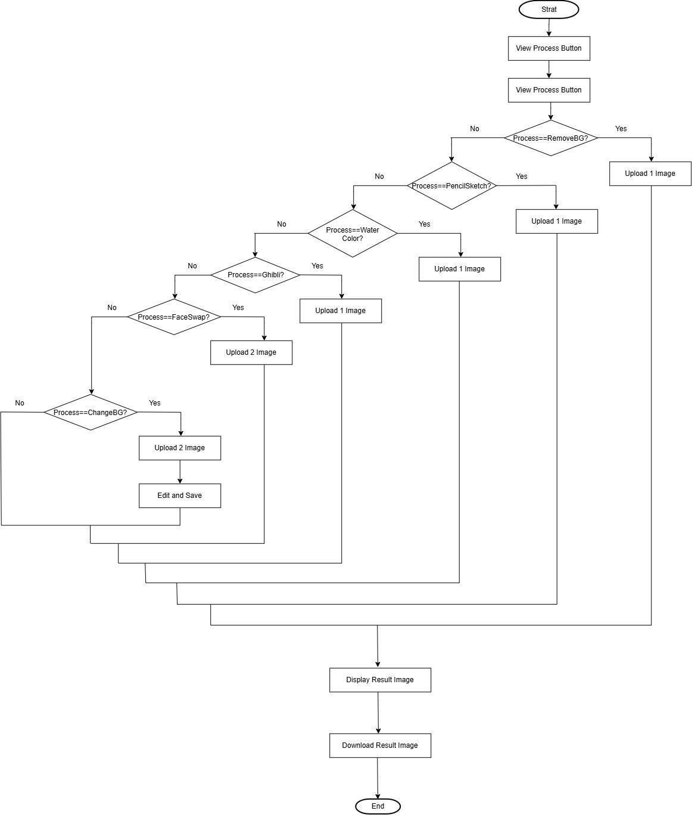
Figure 3.1 System Flow Diagram for Digital Image Processing Module
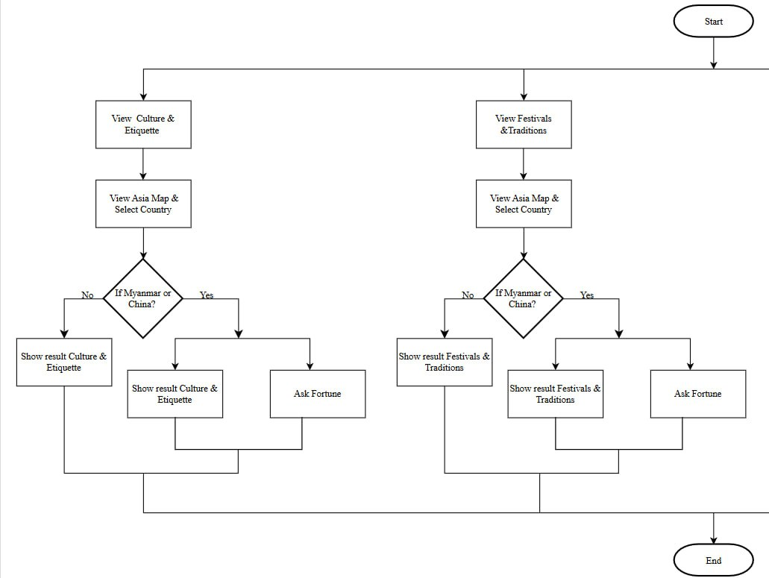
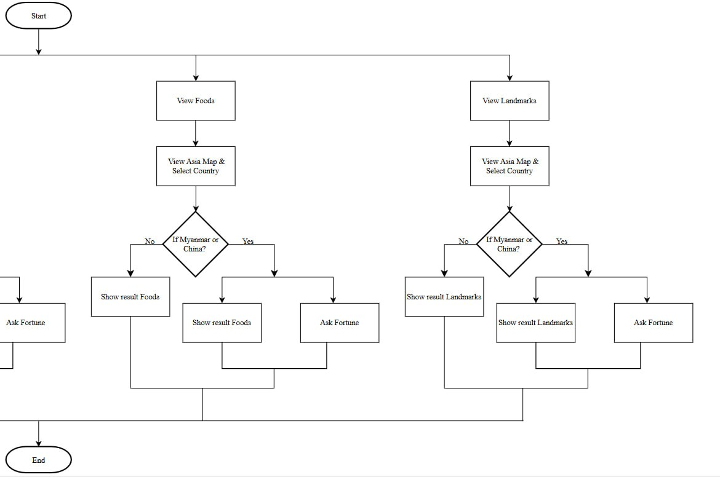
Figure 3.2 System Flow Diagram for Cultural Knowledge Base Module
The system flow begins at the "Start" state, offering the user four distinct navigation paths based on their desired category: View Culture & Etiquette, View Festivals & Traditions, View Foods, or View Landmarks. Upon selecting a category, the user proceeds to the "View Asia Map & Select Country" interface to pick a specific nation for exploration. The workflow then executes a conditional evaluation ("If Myanmar or China?"): if the selected country is neither Myanmar nor China ("No"), the system directly displays the standard categorical result—namely, "Show result Culture & Etiquette", "Show result Festivals & Traditions", "Show result Foods", or "Show result Landmarks". Conversely, if the user selects either Myanmar or China ("Yes"), the system provides the standard categorical output while simultaneously unlocking an additional specialized feature ("Ask Fortune") to grant access to country-specific astrology tools. Finally, all parallel execution paths converge to conclude the user interaction at the "End" node.
3.2 Object Interaction Diagrams
The sequence diagram illustrates the step-by-step interactions between the User, UI, and System during the execution of the Image Processing module. The workflow begins when the user clicks the 'View Process Button', prompting the UI to display the available transformation options, from which the user selects a specific processing feature (such as PencilSketch, RemoveBG, or FaceSwap). Based on the selected feature, the execution branches into an alternative (alt) condition block: single-image transformations—including RemoveBG, PencilSketch, Water Color, and Ghibli—require the user to upload one image, which the UI forwards to the System for processing before receiving the transformed image back; conversely, multi-image features like ChangeBG and FaceSwap require uploading two images, with ChangeBG including an intermediate step where the UI displays edit options for the user to perform edits and save prior to system processing. Once the corresponding backend processing is complete, all conditional branches converge as the UI renders the final result via 'Display Result Image', allowing the user to click 'Download Result Image' to retrieve the output file and successfully terminate the session.

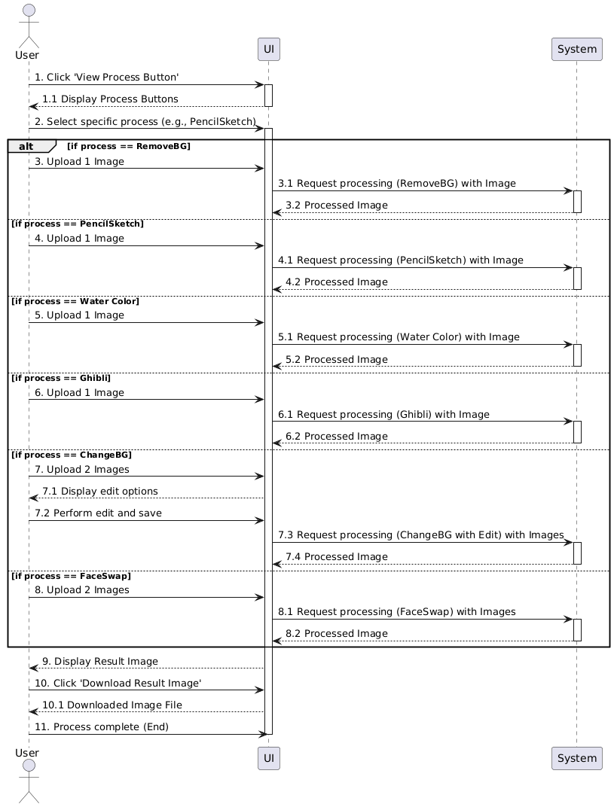
Figure 3.3 Sequence Diagram for Digital Image Processing Module
The sequence diagram depicts the interaction flow between the User, Asia Explorer UI, Content Manager, and Fortune Service during cultural content exploration. The process begins when the user selects a category (e.g., "User Selects View Foods") on the Asia Explorer UI, which invokes showCountrySelection() on the Content Manager to return and render displayMapAndCountryOptions(). Upon selecting a specific nation ("User Selects Country"), an alternative (alt) execution block evaluates the user's country selection: if the chosen country is Myanmar or China, the UI calls askForFortune(), prompting the Content Manager to interact with the Fortune Service to retrieve and present displayFortuneResult(); otherwise (else), the system bypasses the astrology module and invokes displayContentForSelectedCountry() via the Content Manager. Both execution paths finalize by returning displayResult() to the user, who can then end the interaction session ("User Closes View").

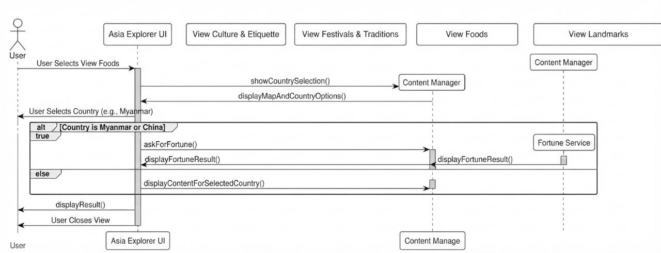
Figure 3.4 Sequence Diagram for Cultural Knowledge Base Module
3.3 Design Patterns
In software engineering, design patterns provide reusable solutions to common software design problems. The Asia Explorer System utilizes structural, creational, and architectural design patterns to maintain modularity, high maintainability, loose coupling, and clear separation of concerns across its cultural, astrological, and image processing subsystems.
3.3.1 Model-View-Controller (MVC) Architectural Pattern
The system heavily applies the Model-View-Controller (MVC) architectural pattern to separate the user interface (Presentation Layer), the business processing logic (Controller), and the underlying data representations (Model). This pattern is used to ensure high maintainability and allows independent development of frontend interfaces and backend logic.
- Model (Data Logic & Processing Services): Encapsulates core database interactions, cultural data schemas, and mathematical calendar/astrology rules.
- View (ASP.NET Presentation Page): Renders the user interface controls such as input textboxes, buttons, validation labels, and image display containers.
- Controller (Code-Behind Logic): Intercepts user actions, processes incoming input data, invokes core business services (e.g., date conversion or image transformation), and dictates navigation flow.
3.3.2. Additional Design & Security Patterns
In addition to the primary architectural pattern, the system incorporates specialized structural and security patterns to protect sensitive project data and maintain a strong security perimeter.
3.3.2.1 Factory Pattern (Creational Pattern)
Applied within the 7-Stage Image Processing Engine, the Factory Pattern is utilized to instantiate specific image processing objects—such as PencilSketchProcessor, RemoveBGProcessor, or FaceSwapProcessor—based on the user’s selected operation. By delegating the creation logic to a centralized factory class, the system abstractly returns the appropriate processor interface without exposing instantiation details directly to the main controller. This design approach promotes loose coupling and strictly adheres to the Open/Closed Principle (OCP), allowing developers to seamlessly integrate new image processing filters and algorithms in the future without altering existing controller logic or core execution code.
3.3.2.2 Strategy Pattern (Behavioral Pattern)
Applied within the Specialized Country Modules (Myanmar and China Astrology Engines), the Strategy Pattern defines a family of astrological algorithms—such as Myanmar Mahabote calculations and Chinese Bazi horoscope models—encapsulating each algorithm into a separate strategy class and making them fully interchangeable. When a user requests astrological insights for a specific country like Myanmar or China, the system dynamically selects and executes the appropriate calculation strategy at runtime. This structural approach enables clean conditional execution by eliminating cluttered if-else branching within the primary application flow, while effectively isolating complex astrological mathematical models into independent, maintainable units.

CHAPTER 4
DATABASE DESIGN
This chapter focuses on the database architecture and data management strategies required to support the Asia Explorer System. It outlines the structural framework for organizing static cultural content, image processing configurations, astrological algorithms, and user analytics data to ensure efficient retrieval, secure storage, and system reliability.
The chapter begins with the Requirement and Database Design Phase, defining core application specifications across four operational modules: Cultural Knowledge Base, Image Processing Engine, Astrology Engine, and User Management & Analytics. It then details the Database Schema Design, highlighting the hybrid approach of using a structured file directory system (/Global/images/) for static Asian cultural profile assets alongside an embedded SQLite3 database (asia_explorer.db) for storing persistent user demographic metrics. Finally, it presents the relational schema structure, SQL table definitions, indexing techniques, and a comprehensive Data Dictionary that specifies the column attributes, data types, and integrity constraints for system analytics.
4.1 Requirement and Database Design Phase
This phase outlines the core application specifications and the underlying database schema necessary to support the Asia Explorer System, ensuring seamless data retrieval for cultural profiles alongside secure persistence for user activity analytics.
4.1.1 Application Requirement
The system requirements are structured across four main operational modules to fulfill functional and technical expectations:
- Cultural Knowledge Base Requirements:
  - Must store and serve structured information for 48 Asian countries, covering culture, etiquette, traditions, foods, and landmarks.
  - Must enforce map-based interactive country selection prior to displaying localized data.
- Image Processing Engine Requirements:
  - Must support single-image processing filters (RemoveBG, PencilSketch, WaterColor, Ghibli) and dual-image processing models (ChangeBG, FaceSwap).
  - Must validate file formats (.jpg, .jpeg, .png) and enforce a maximum file size limit of 10 MB per upload.
- Astrology Engine Requirements:
  - Must dynamically execute specialized calculation engines for Myanmar (Mahabote/Myanmar Era calendar) and China (Bazi zodiac horoscope models).
  - Must validate completeness of user inputs (birth date, time, day) prior to running algorithms.
- User Management & Analytics Requirements:
  - Must capture user profile attributes (name and age) with client-side and server-side validation.
  - Must aggregate user demographic metrics into age groups (1-17, 18-25, 26-40, 41-60, 61+) for system analytics dashboards.
4.1.2 Design the Database Schema (48 Countries Data & User Analytics)
The data persistence layer is powered by an embedded SQLite3 database (asia_explorer.db), managing static cultural routing assets alongside user demographic metrics.
1. Static Directory Data Design (48 Countries Cultural Data)
To optimize speed and prevent database overhead for heavy media content, cultural information for the 48 Asian countries is organized via a structured directory routing system (Global/images/) mapped via Flask endpoints:
- Country Profile Entities: Includes country identification keys, geographical tags, cultural etiquette summaries, festival guides, local cuisine records, and landmark photo assets.
2. User Analytics Entity Schema (users Table) User registration, age demographic tracking, and audit metrics are persisted in the relational database using the following SQL schema:

CREATE TABLE IF NOT EXISTS users (
id INTEGER PRIMARY KEY AUTOINCREMENT,
name TEXT NOT NULL CHECK (length(trim(name)) BETWEEN 1 AND 80),
age INTEGER NOT NULL CHECK (age BETWEEN 1 AND 120),
created_at TEXT NOT NULL DEFAULT (datetime('now')),
updated_at TEXT NOT NULL DEFAULT (datetime('now'))
);

CREATE INDEX IF NOT EXISTS idx_users_created_at ON users (created_at);
```[cite: 1]

ဤအဆင့်သည် **Asia Explorer System** တစ်ခုလုံး အဆင်ပြေချောမွေ့စွာ လည်ပတ်နိုင်ရန် လိုအပ်သော စနစ်ဆိုင်ရာ သတ်မှတ်ချက်များနှင့် ဒေတာများကို တိကျစွာ သိမ်းဆည်းပေးမည့် ဒေတာဘေ့စ် စနစ် ဖွဲ့စည်းပုံကို ဖော်ပြခြင်း ဖြစ်ပါသည်။

**၅.၁.၁ စနစ်ဆိုင်ရာ လိုအပ်ချက်များ (Application Requirement)**
* **ယဉ်ကျေးမှုဆိုင်ရာ ဒေတာဘဏ်:** အာရှ ၄၈ နိုင်ငံ၏ ယဉ်ကျေးမှု၊ ဓလေ့ထုံးတမ်း၊ ပွဲတော်များ၊ အစားအစာများနှင့် အထင်ကရနေရာများဆိုင်ရာ အချက်အလက်များကို အာရှမြေပုံပေါ်တွင် ရွေးချယ်မှုပြုလုပ်ပြီးမှသာ သီးသန့် ထုတ်ယူပြသပေးရပါမည်။
* **ပုံရိပ်ပြုပြင်ဖန်တီးမှု အင်ဂျင်:** ပုံ ၁ ပုံသုံး လုပ်ဆောင်ချက်များ (*RemoveBG*, *PencilSketch*, *WaterColor*, *Ghibli*) နှင့် ပုံ ၂ ပုံသုံး လုပ်ဆောင်ချက်များ (*ChangeBG*, *FaceSwap*) တို့ကို ထောက်ပံ့ပေးရမည်ဖြစ်ပြီး၊ Upload တင်သည့် ပုံရိပ်များကို 10 MB အထိသာ ခွင့်ပြုပါမည်။
* **ဗေဒင်တွက်ချက်မှု အင်ဂျင်:** မြန်မာ့ မဟာဘုတ်နှင့် တရုတ် ဗာဇီ (Bazi) ဗေဒင် တွက်ချက်မှု မော်ဒယ်များအတွက် မွေးသက္ကရာဇ်၊ မွေးဖွားချိန်နှင့် မွေးနေ့ စသည့် အချက်အလက်များကို တိကျစွာ စစ်ဆေး လက်ခံရပါမည်။
* **အသုံးပြုသူ မက်ထရစ်နှင့် Analytics:** သုံးစွဲသူများ၏ Profile (`name`, `age`) ကို တိကျစွာ လက်ခံ၍[cite: 1, 2]၊ အသက်အရွယ် အပိုင်းအခြား အလိုက် (`1-17`, `18-25`, `26-40`, `41-60`, `61+`) Analytics Chart များအဖြစ် ပြန်လည် ထုတ်ယူပြသပေးရပါမည်[cite: 2]။

**၅.၁.၂ ဒေတာဘေ့စ် ဒီဇိုင်း (Design the Database Schema - 48 Countries Data)**
* **အာရှ ၄၈ နိုင်ငံဆိုင်ရာ ဒေတာ:** ဒေတာဘေ့စ် ဝန်ပိမှုကို သက်သာစေရန် နိုင်ငံ ၄၈ နိုင်ငံ၏ ယဉ်ကျေးမှုဆိုင်ရာ ပုံရိပ်များနှင့် စာသားများကို Structured Directory (`Global/images/`) ဖြင့် စနစ်တကျ သိမ်းဆည်းပြီး Flask Backend Route များမှတစ်ဆင့် ပို့ဆောင်ပေးပါသည်။
* **အသုံးပြုသူ ဒေတာဘေ့စ် (`users` Table):** သုံးစွဲသူများ၏ အချက်အလက်များနှင့် Analytics ရလဒ်များကို SQLite3 (`asia_explorer.db`) တွင် `users` Table ဖန်တီး၍[cite: 1, 2]၊ `id`, `name`, `age`, `created_at` နှင့် `updated_at` Column များဖြင့် တိကျစွာ ထိန်းသိမ်းထားပါသည်။ `created_at` ပေါ်တွင် Index ထည့်သွင်းထားသောကြောင့် ဒေတာ ရှာဖွေမှုများကို မြန်ဆန်စေပါသည်။[cite: 1]

**Data Dictionary Table:**
| Column Name | Data Type | Constraints | Description |
| :--- | :--- | :--- | :--- |
| **`id`** | `INTEGER` | `PRIMARY KEY`, `AUTOINCREMENT` | Unique identifier for the user profile entry[cite: 1]. |
| **`name`** | `TEXT` | `NOT NULL`, `CHECK (1-80 chars)` | User's full name (1 to 80 characters)[cite: 1]. |
| **`age`** | `INTEGER` | `NOT NULL`, `CHECK (1 to 120)` | User's age bound between 1 and 120 years[cite: 1]. |
| **`created_at`** | `TEXT` | `NOT NULL`, `DEFAULT (now)` | Timestamp recording profile creation[cite: 1]. |
| **`updated_at`** | `TEXT` | `NOT NULL`, `DEFAULT (now)` | Timestamp tracking recent updates[cite: 1]. | --- ။[cite: 1]

CHAPTER 5
SYSTEM DESIGN AND DEVELOPMENT
This chapter focuses on the practical implementation, tools setup, and graphical interface realization of the Asia Explorer System. It details the physical hardware environment, software stack, third-party libraries, and the structural integration required to transform design models into a fully functioning multi-tiered web application.
The chapter begins with the Tools Development Environment, specifying the hardware configurations, core programming technologies (HTML5, CSS3, JavaScript ES6+, Python Flask), image processing libraries (OpenCV, PIL), and software tools (Visual Studio Code, PyCharm, Draw.io) utilized during system development. It then highlights the System Dependencies and Libraries Integration, explaining how backend frameworks and computer vision engines interact seamlessly. Finally, the chapter presents the System Implementation phase alongside actual user interface screenshots, showcasing the operational workflows for the Home Page, Interactive Asian Culture & Etiquette Map, Zodiac & Chinese Astrology Modules, Zodiac Couple Compatibility, and Myanmar Mahabote Horoscope Engines.
5.1 Tools Development Environment
The development environment for the Asia Explorer System is structured using a combination of web technologies, backend frameworks, and specialized image processing libraries. The environment ensures a responsive user interface, efficient database operations, and high-performance execution of image transformation pipelines and astrological algorithms.
5.1.1 Hardware Specifications
The minimum and recommended hardware configurations utilized during system development and testing are as follows:
- Processor (CPU): Intel Core i5 / AMD Ryzen 5 (8th Generation or higher)
- Random Access Memory (RAM): 8 GB minimum (16 GB recommended for smooth OpenCV processing)
- Storage: 256 GB Solid State Drive (SSD)
- Display: 1920 x 1080 Full HD Resolution Display
5.1.2 Software Specifications & Tools

Table 5.1 Software Specifications & Tools
Category | Technology / Tool Used | Purpose / Scope in Project
Frontend Technologies | HTML5, CSS3, JavaScript (ES6+) | Constructing responsive user interfaces for 48 Asian country profiles, interactive maps, and processing dashboards.
Backend Framework | Python (Flask Framework) / Node.js | Handling client requests, managing route endpoints, and serving API responses for cultural and astrological features.
Core Programming Languages | Python, JavaScript | Writing core business logic, algorithm pipelines, and frontend interactive event listeners.
Image Processing Libraries | OpenCV, PIL (Pillow), EmguCV | Executing the 7-stage image processing pipeline (FaceSwap, RemoveBG, Ghibli, PencilSketch, WaterColor, ChangeBG).
Development Environment (IDE) | Visual Studio Code / PyCharm | Primary Code Editors for backend service development, script debugging, and frontend integration.
Diagramming & Design Tools | PlantUML, Mermaid.js, Draw.io | Modeling UML diagrams, including Sequence Diagrams, System Flowcharts, and Architecture Schemas.

5.1.3 System Dependencies and Libraries Integration
The system leverages key Python and JavaScript packages to ensure smooth operation across modules:
- OpenCV (opencv-python): Utilized for computer vision tasks, edge detection (Canny/Sobel), face detection, and custom matrix color transformations.
- Pillow (PIL): Applied for lightweight image manipulations, color channel adjustments, file format conversions, and lossless web compression.
- EmguCV: Integrated where .NET wrapper capabilities are required for OpenCV cross-platform feature operations.
- Flask Core & CORS (flask, flask-cors): Facilitates RESTful API request handling and enables cross-origin resource sharing between the JavaScript frontend and Python backend engines.
5.2 System Implementation
This section details the practical realization of the Asia Explorer System, highlighting how the three core architectural pillars—the 48 Asian Countries Cultural Knowledge Base, the 6-Stage Image Processing, and the Specialized Astrology & Calendar Modules—were built, integrated, and executed. The implementation process focuses on establishing robust communication between the responsive JavaScript-based frontend interface and the Python backend services. Key development milestones include the implementation of algorithmic pipelines using OpenCV and PIL for advanced image transformations, the construction of mathematical conversion engines for Myanmar Era (ME) calendar charts and Chinese Zodiac calculations, and the structured retrieval of multi-regional cultural datasets. Furthermore, strict software engineering practices—such as design pattern integration and modular API routing—were enforced to ensure high maintainability, low system latency, and seamless end-to-end execution across all functional modules.
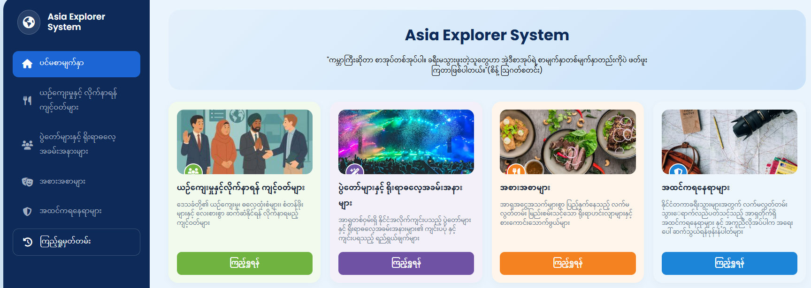
Figure 5.1 Home Page
This is the home page of the Asia Explorer System, displaying the main categories for exploring Asian cultures, festivals, foods, and famous landmarks.
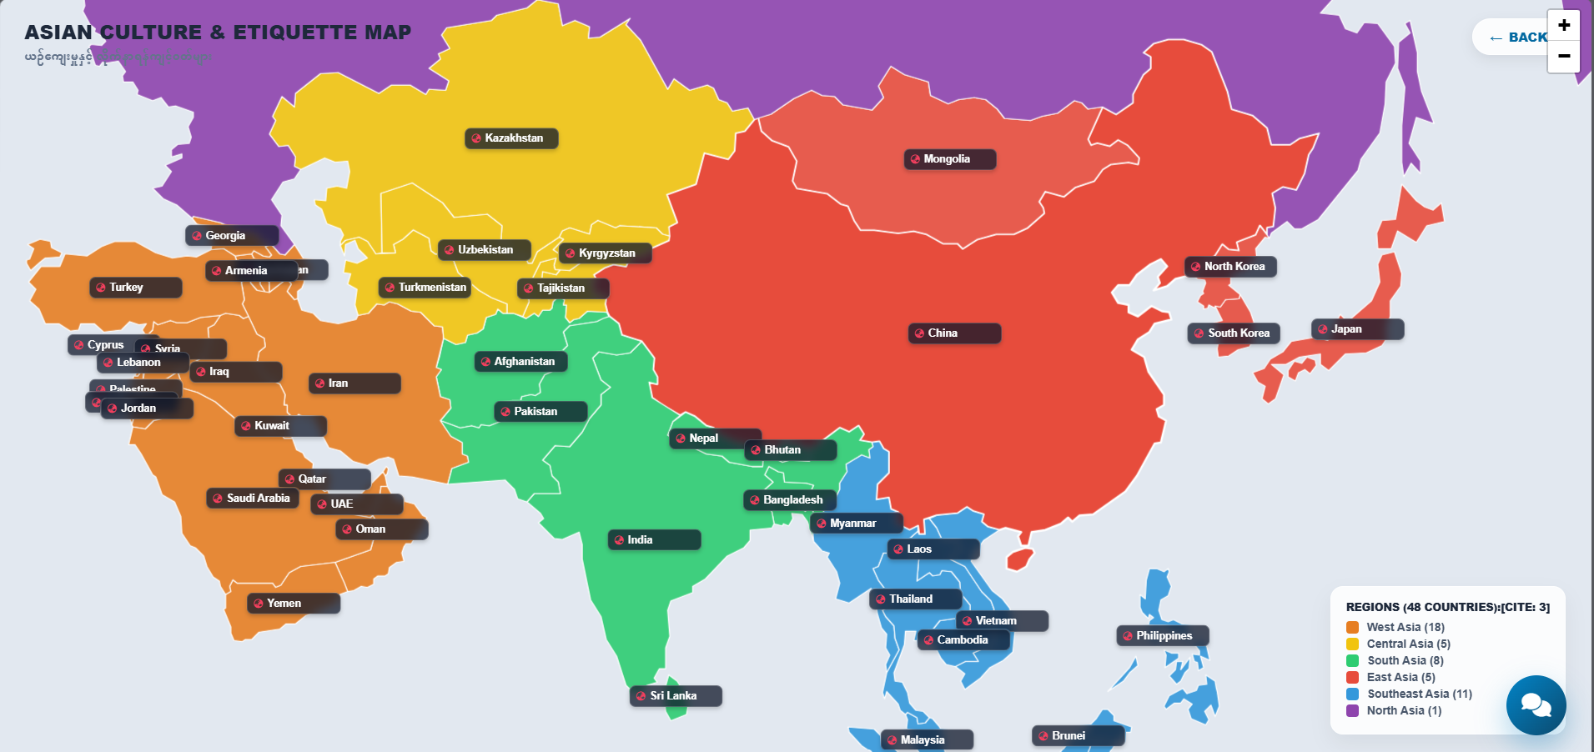
Figure 5.2 Asian Culture & Etiquette Map
This is the Asian Culture and Etiquette Map, displaying countries across Asia for exploring their cultural information and etiquette.
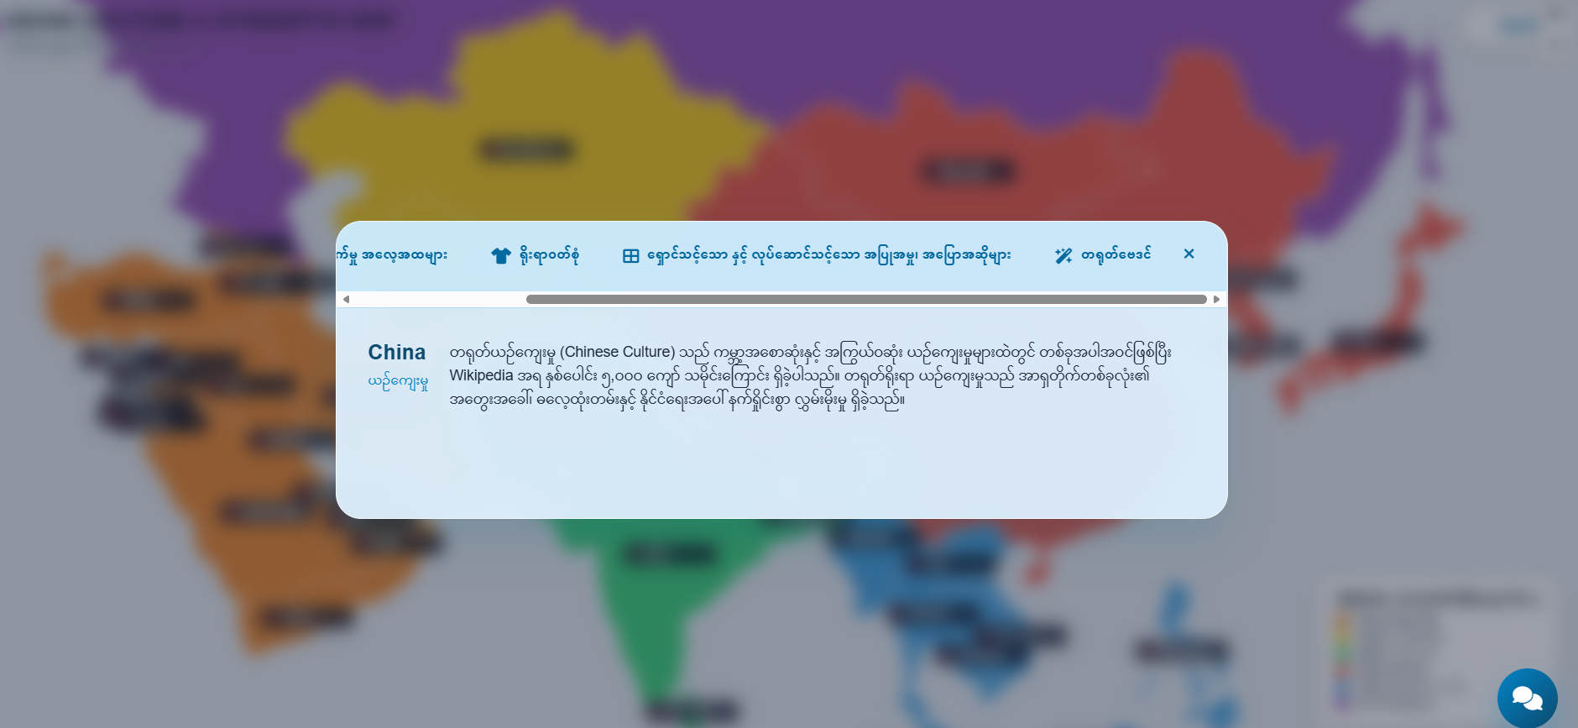
Figure 5.3 Asian Culture & Etiquette Information
Clicking on China on the map opens an interactive pop-up window displaying cultural information.
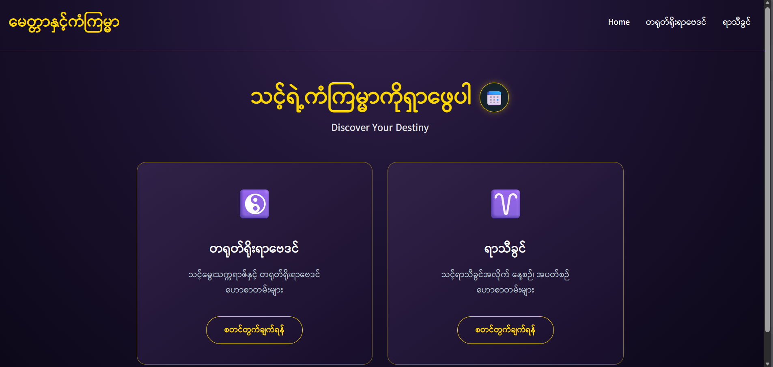
Figure 5.4 Chinese Astrology & Zodiac
Clicking the Chinese Astrology option in the China pop-up redirects users to the “Discover Your Destiny” interface, which provides horoscope calculations based on birth year and zodiac signs, as well as a bidirectional date converter between the Myanmar Era and the Gregorian calendar.
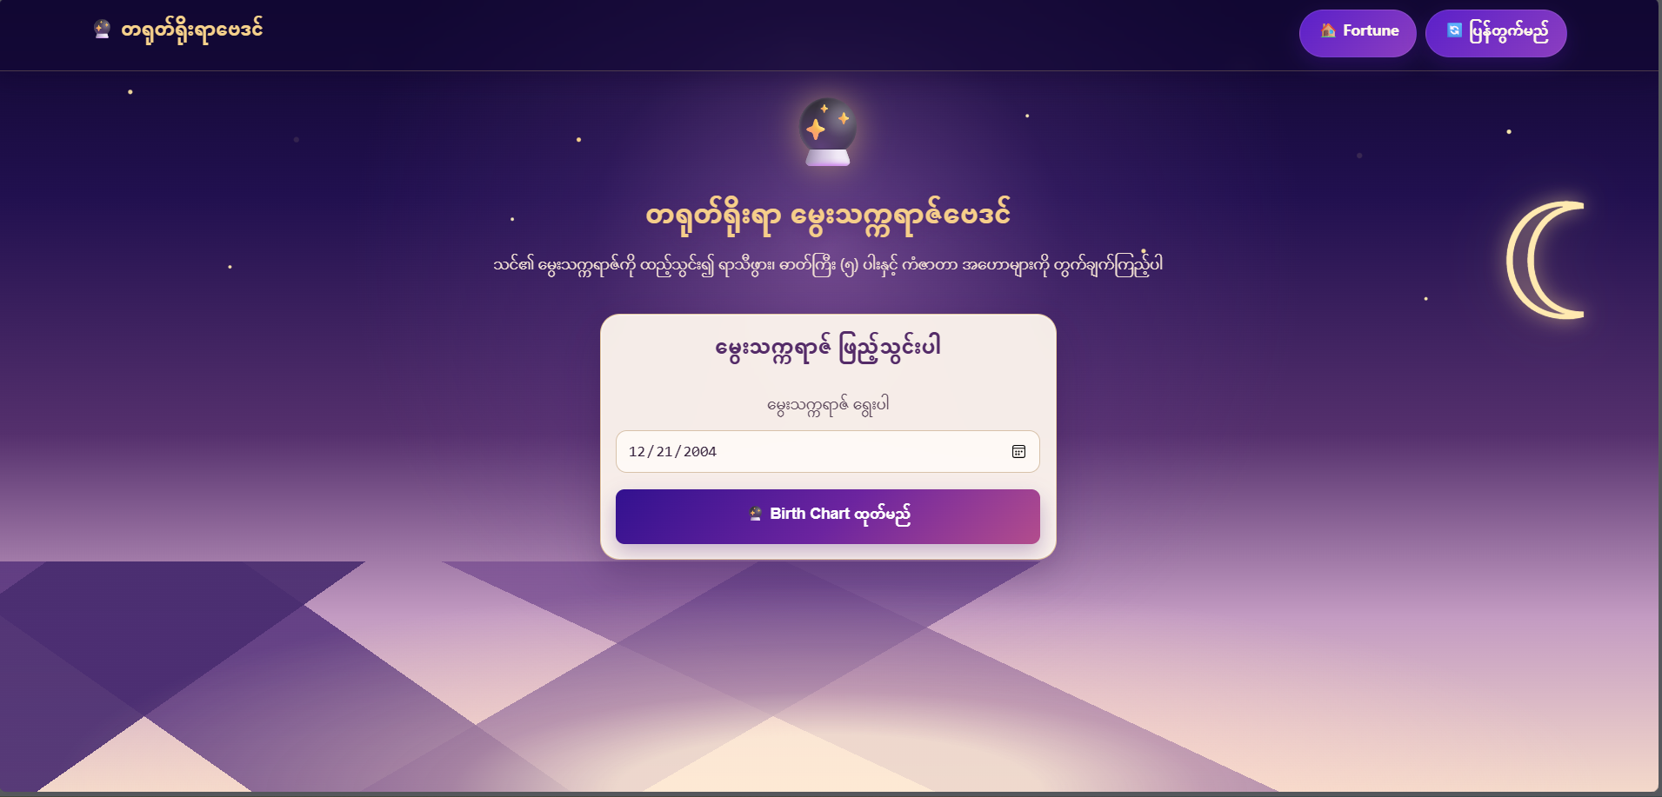
Figure 5.5 Chinese Astrology
This is a Birth Chart Web Page where users can enter their date of birth and calculate their birth chart. By clicking the ‘Calculate Birth Chart’ button, users can view their astrological information.
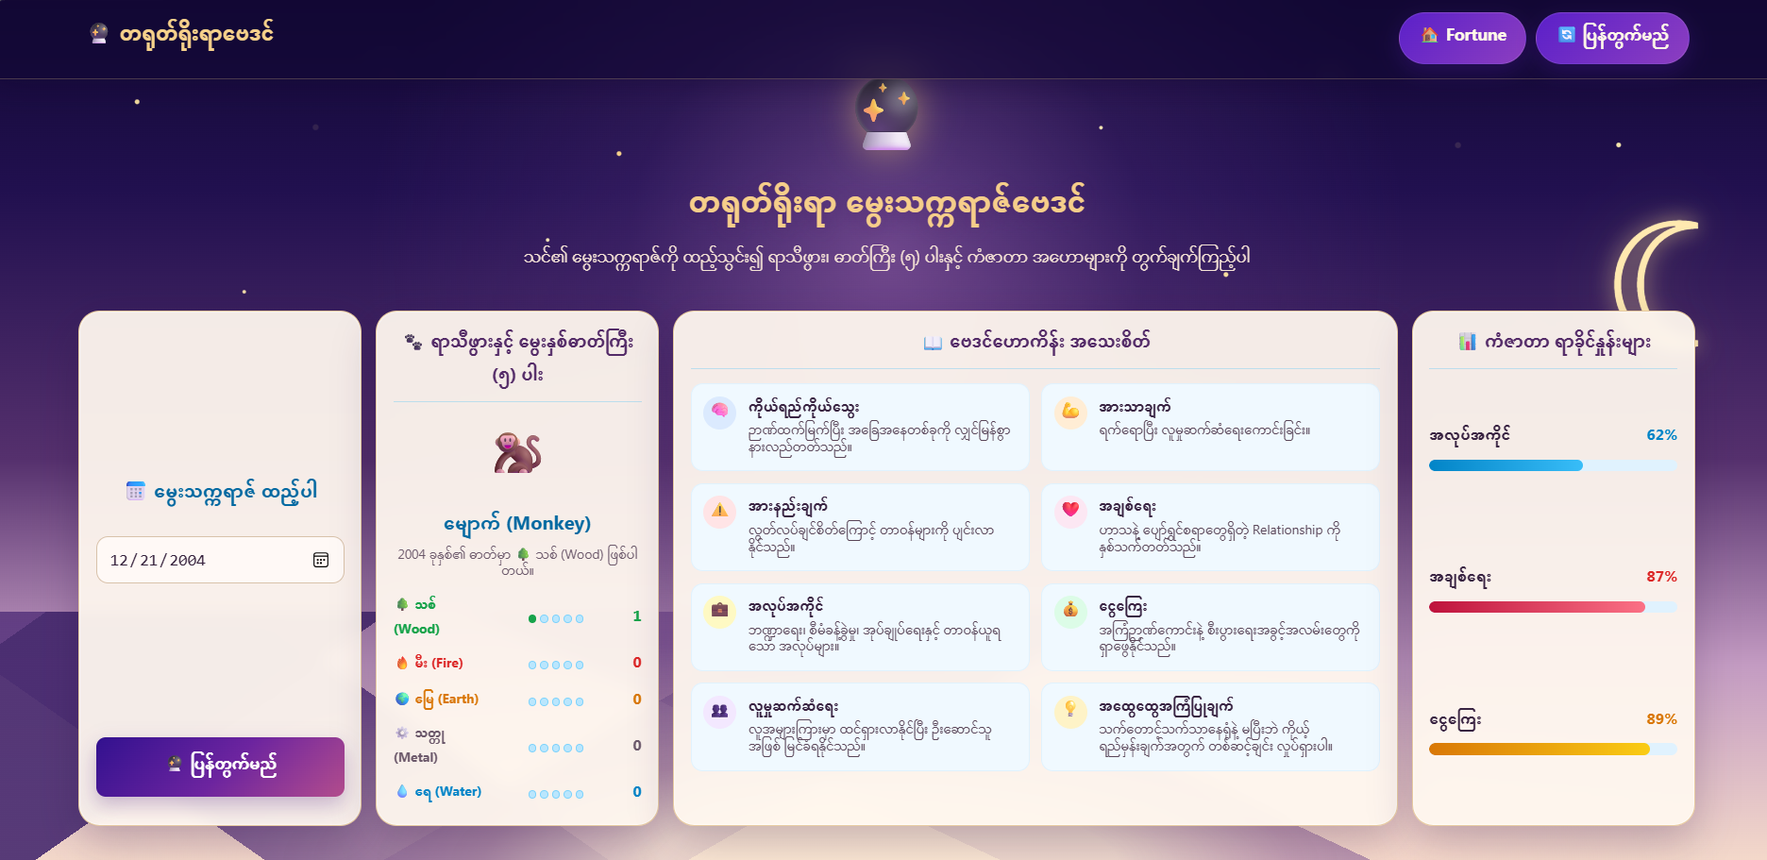
Figure 5.6 Chinese Astrology Result
This page displays the calculated Birth Chart results based on the user’s date of birth.

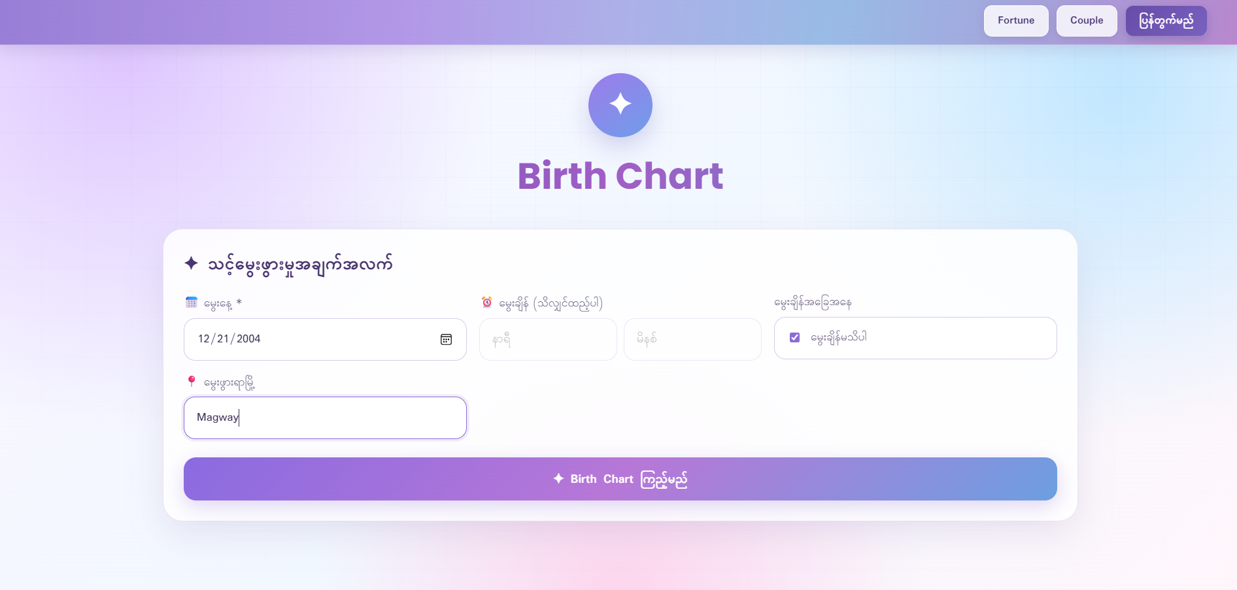
Figure 5.7 Zodiac
Users can enter their information and view their Birth Chart.

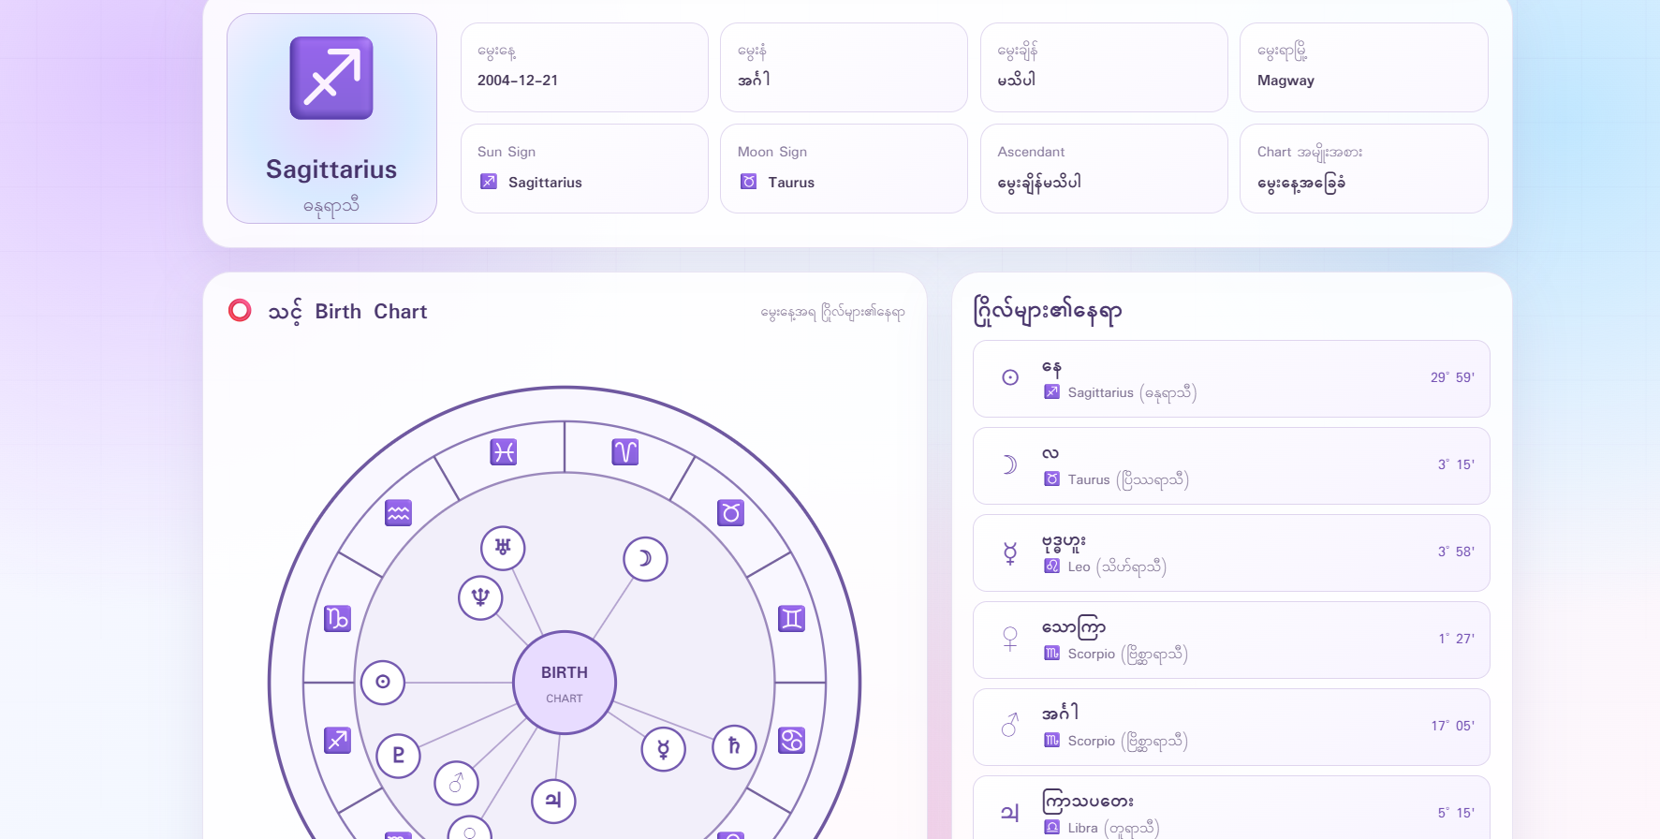
Figure 5.8 Zodiac Result
The Birth Chart results are displayed based on the user's birth information.

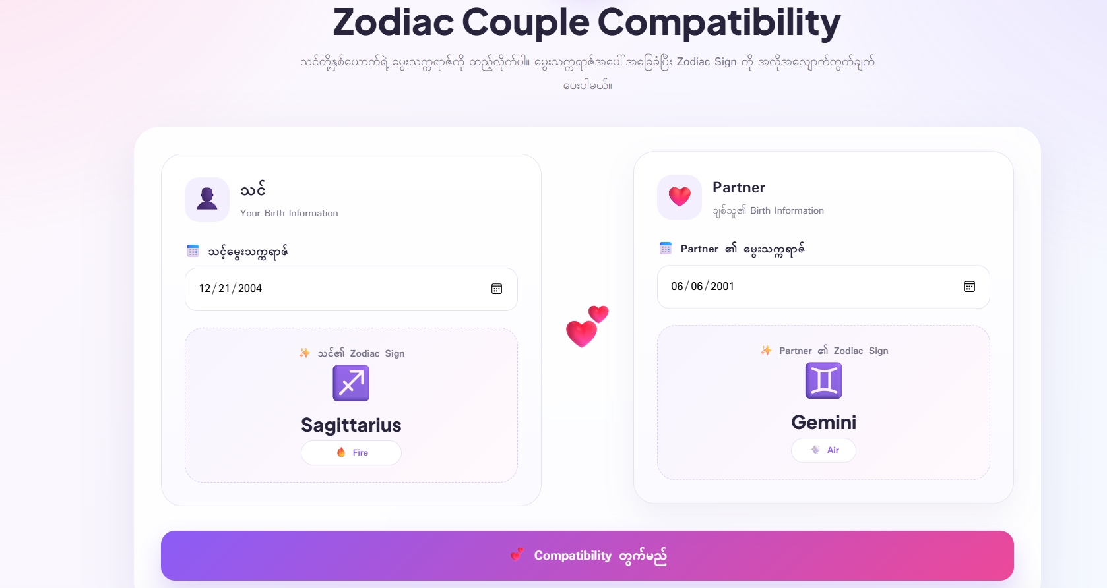
Figure 5.9 Zodiac Couple
The user enters their birth date and their partner’s birth date to calculate their compatibility.
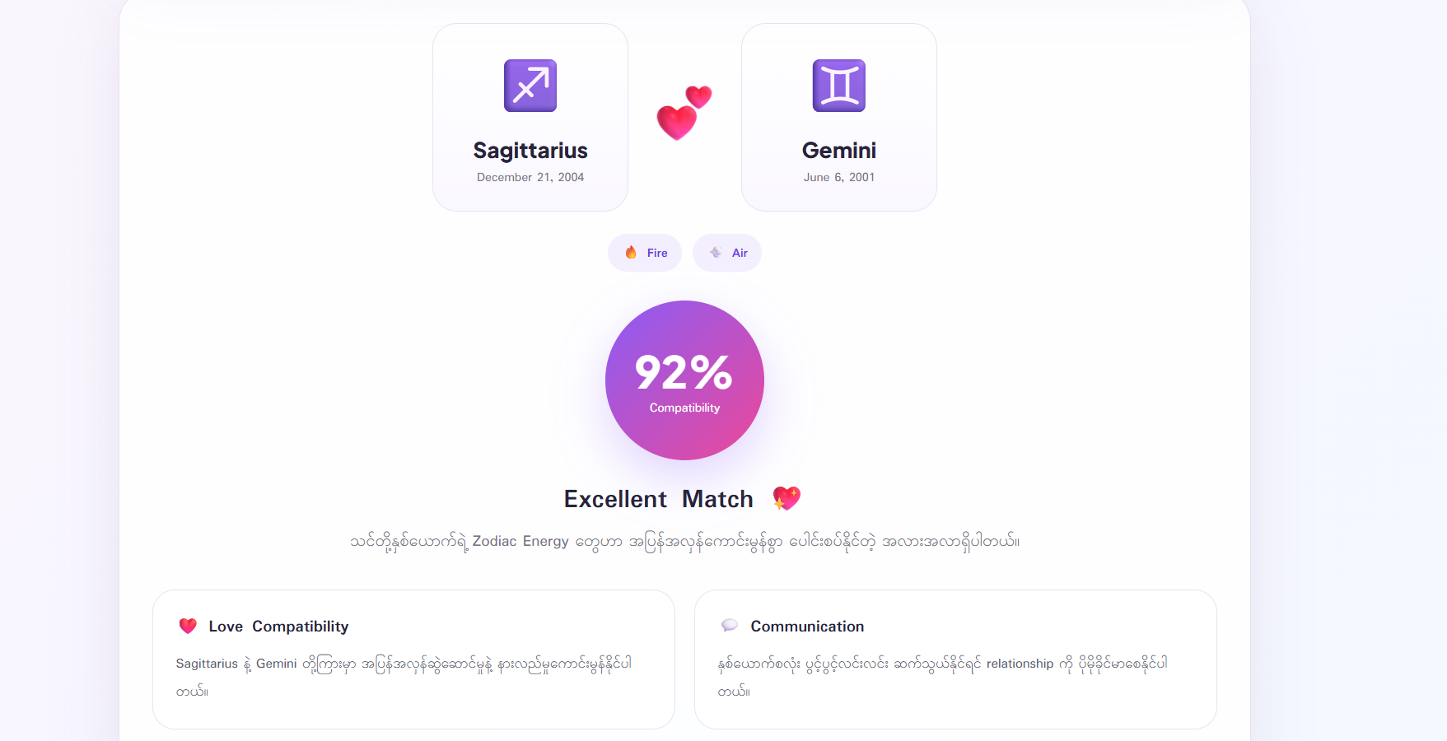
Figure 5.10 Zodiac Couple Result
The birth dates of the user and their partner are entered and calculated to display the resulting information.

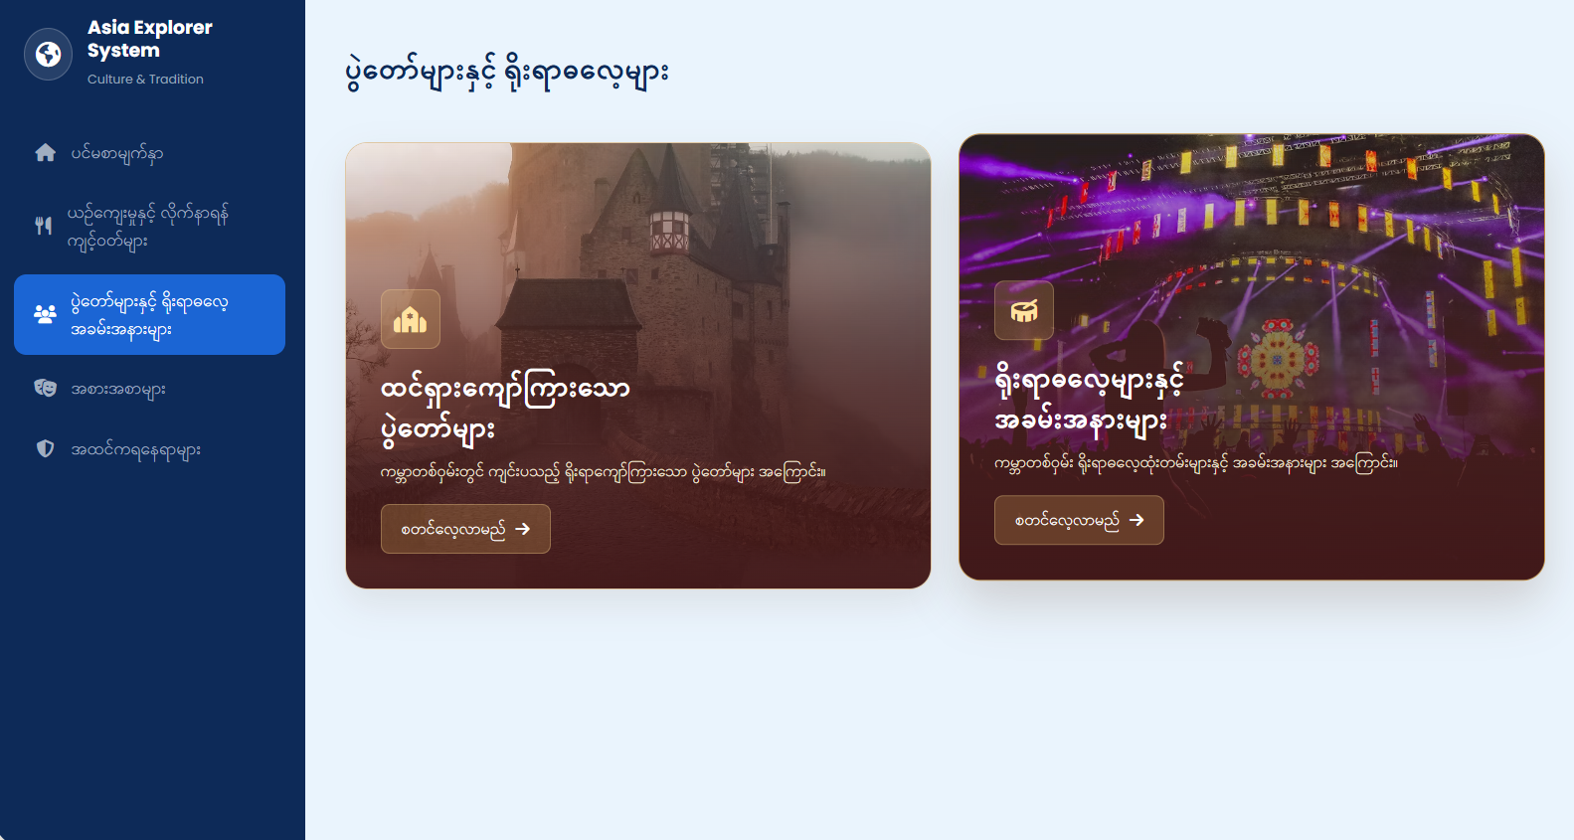
Figure 5.11 Festivals & Traditions
This page enables users to explore Asian-famous festivals and traditional ceremonies categorized into detailed topics.

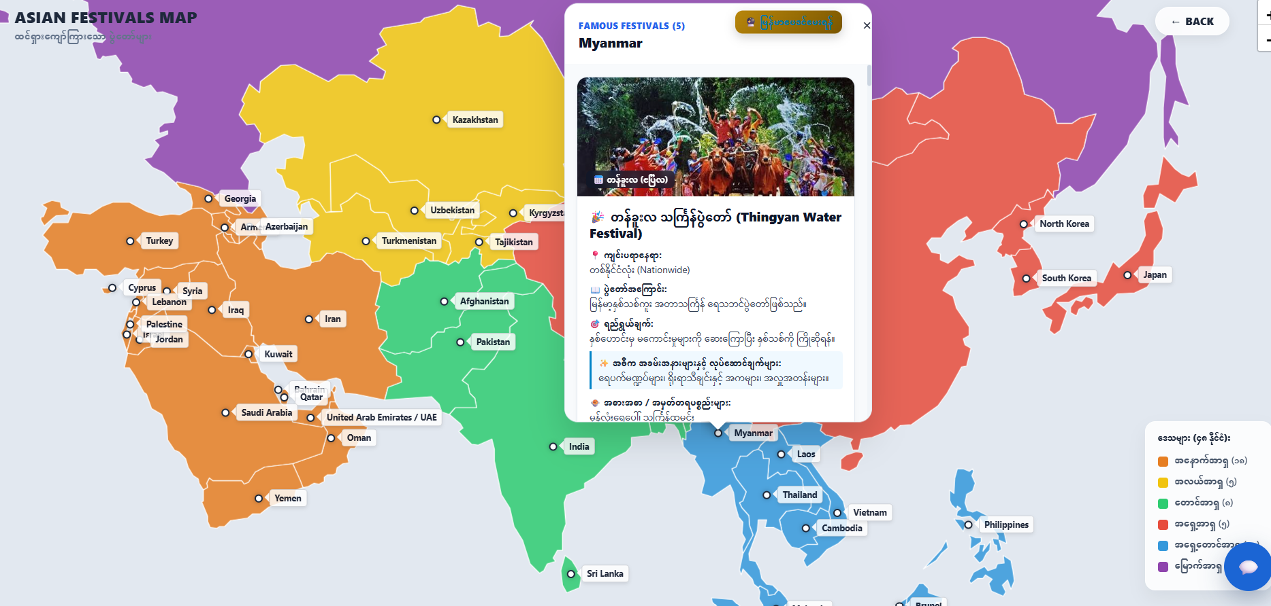
Figure 5.12 Famous Festivals Result
This page features an interactive map of Asia that allows users to click on different countries to explore their famous festivals, locations, history, and traditions.

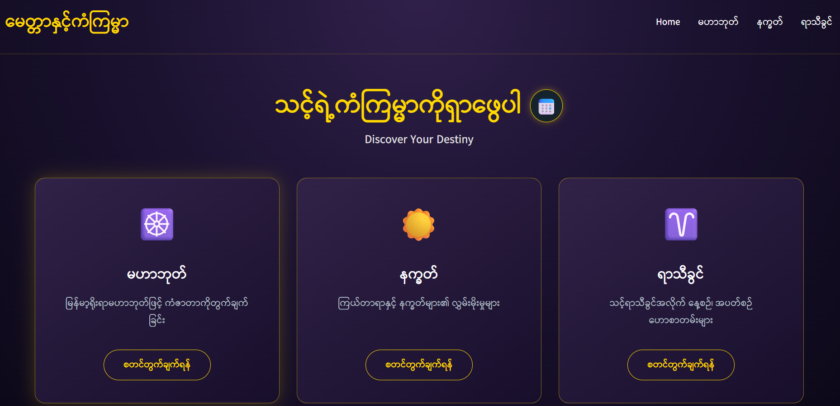
Figure 5.13 Myanmar Astrology
This page allows users to discover their destiny and astrology insights through Mahabote calculations, astrology signs, and zodiac predictions.

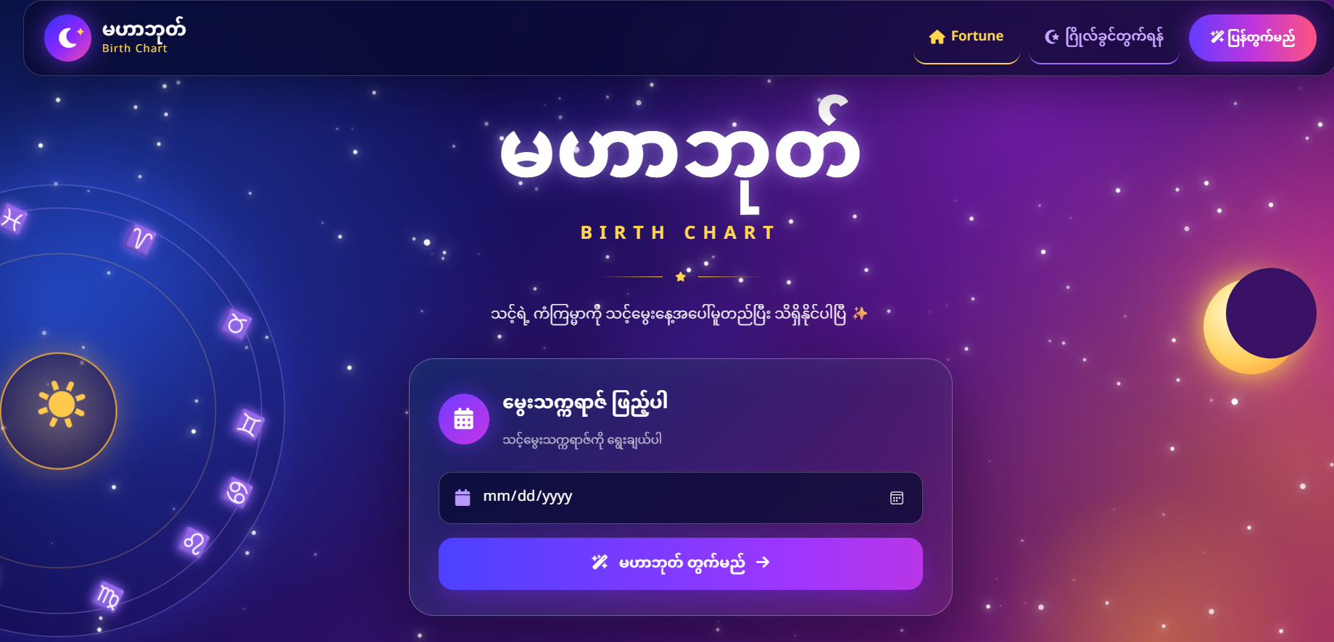
Figure 5.14 Mahabote Astrology
This page allows users to enter their date of birth to calculate and generate their Mahabote birth chart and astrological readings.

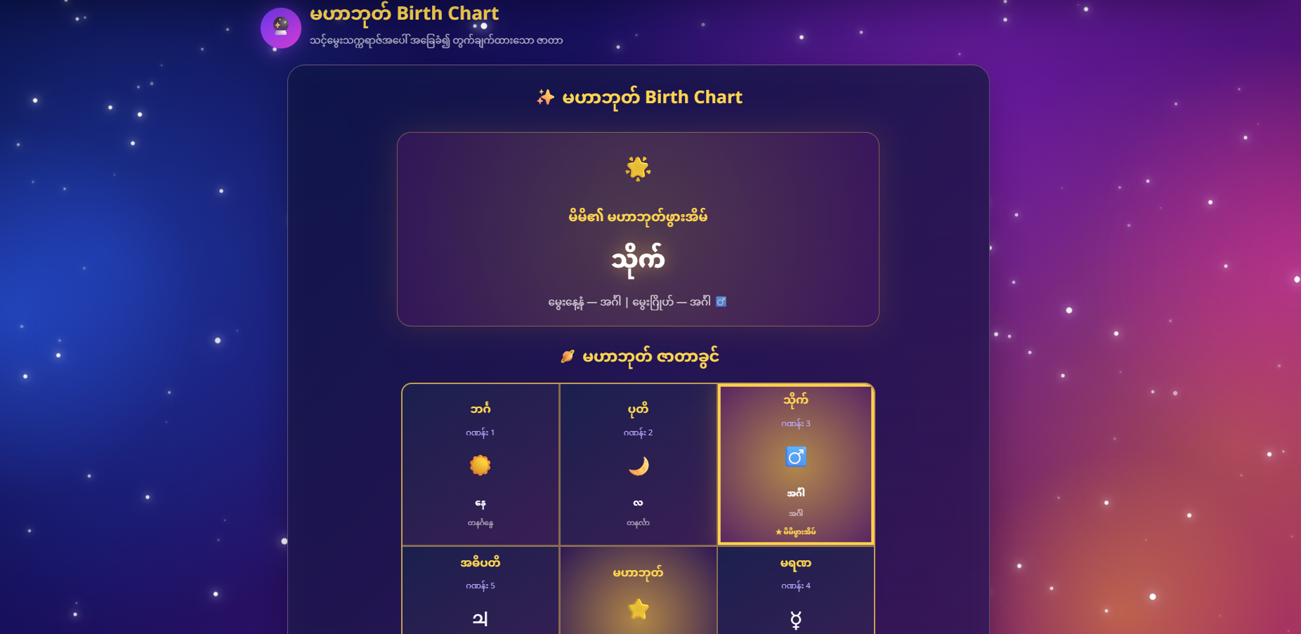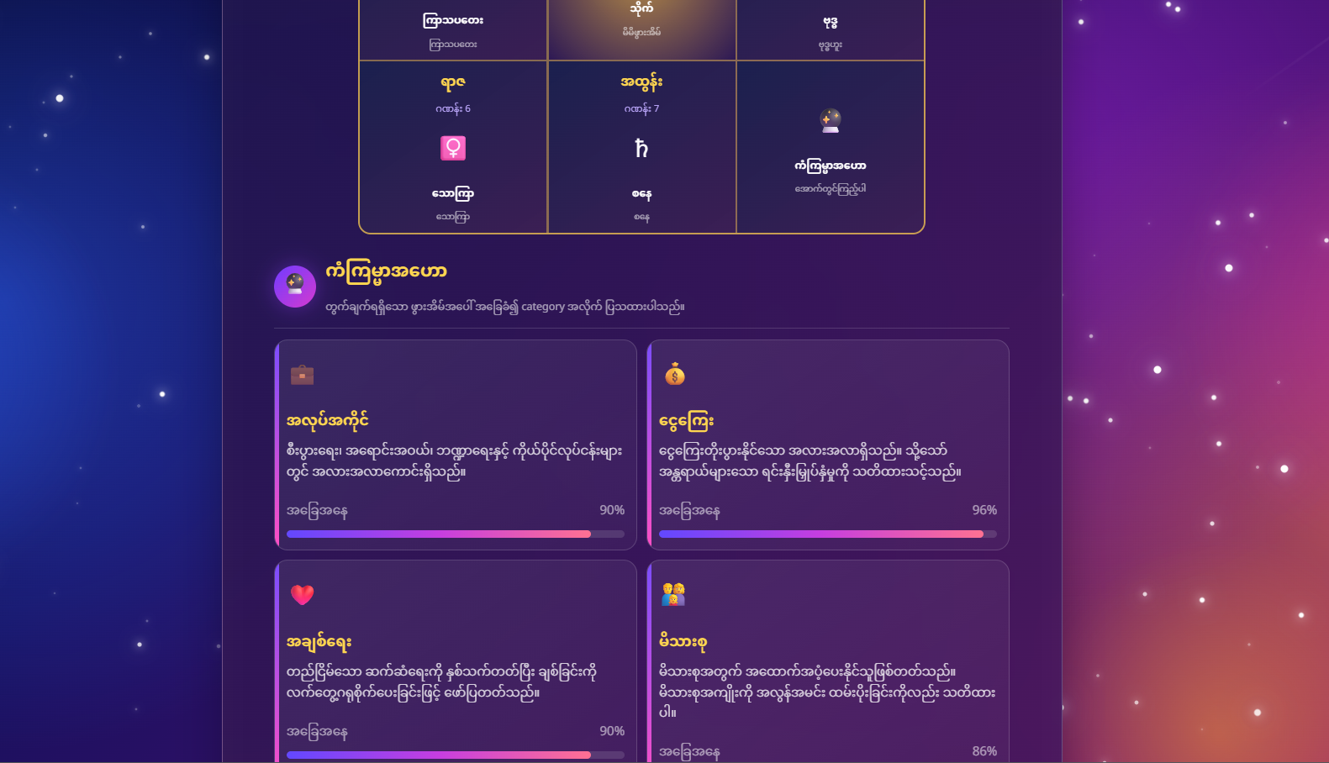
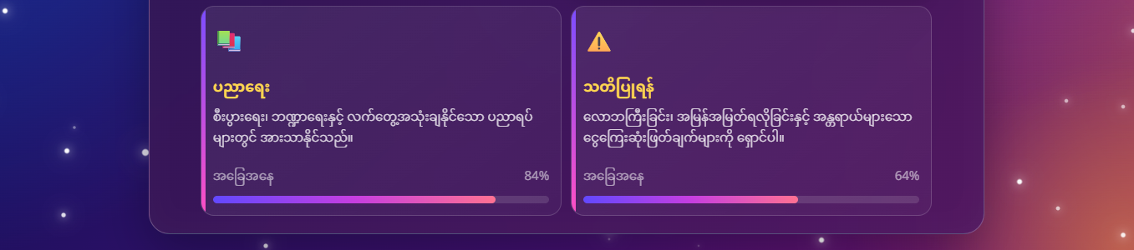
Figure 5.15 Mahabote Astrology Result
This page displays the generated Mahabote birth chart result, showing the user's specific birth house and astrological placement based on their date of birth.

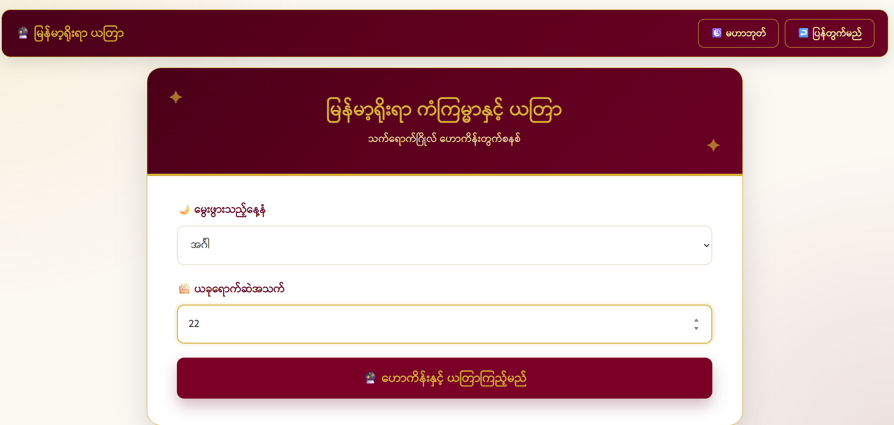
Figure 5.16 Planetary Positions & House
This page enables users to check traditional Myanmar astrological forecasts and remedies by inputting their birthday and age.

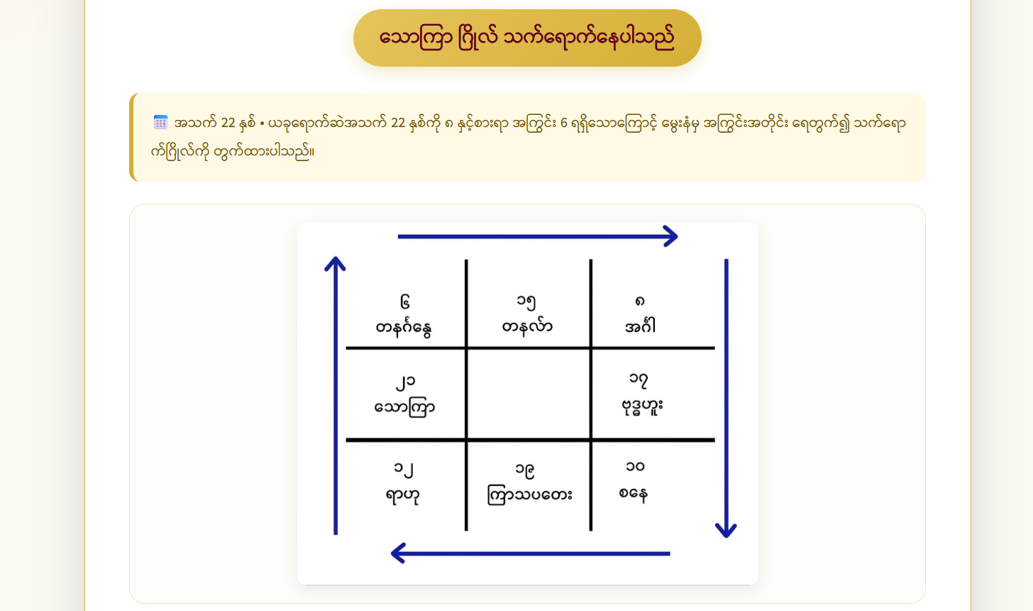
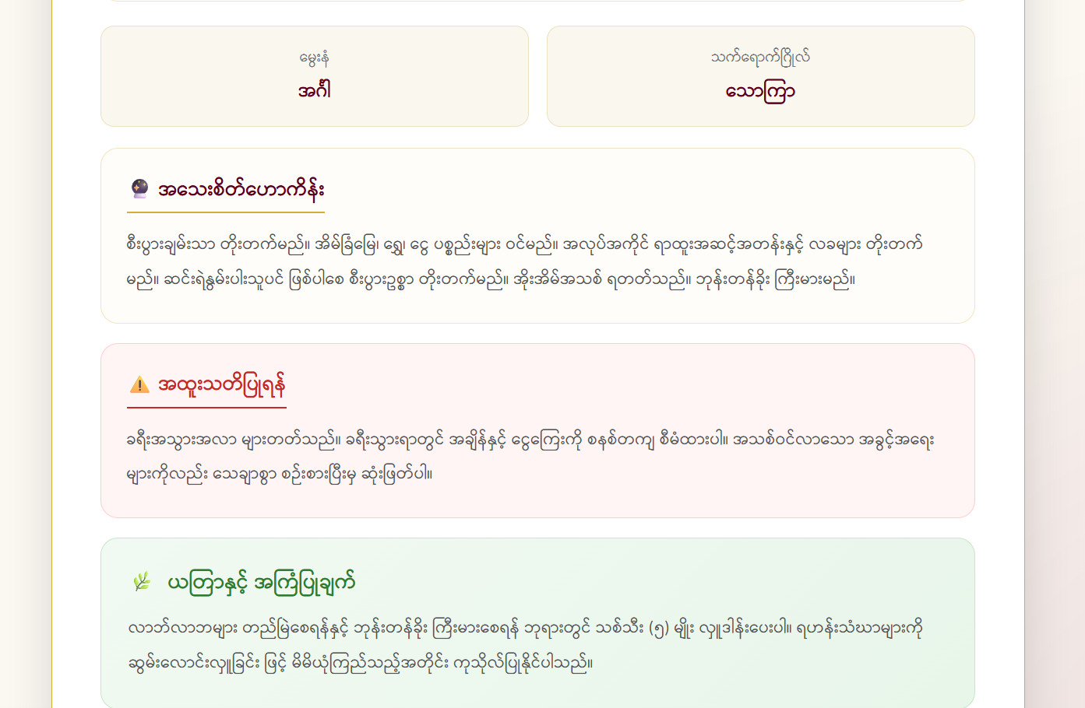
Figure 5.17 Planetary Positions & House Result
This page displays the calculated planetary influence (e.g Venus influence) along with the calculation chart based on the user's age and birth day.

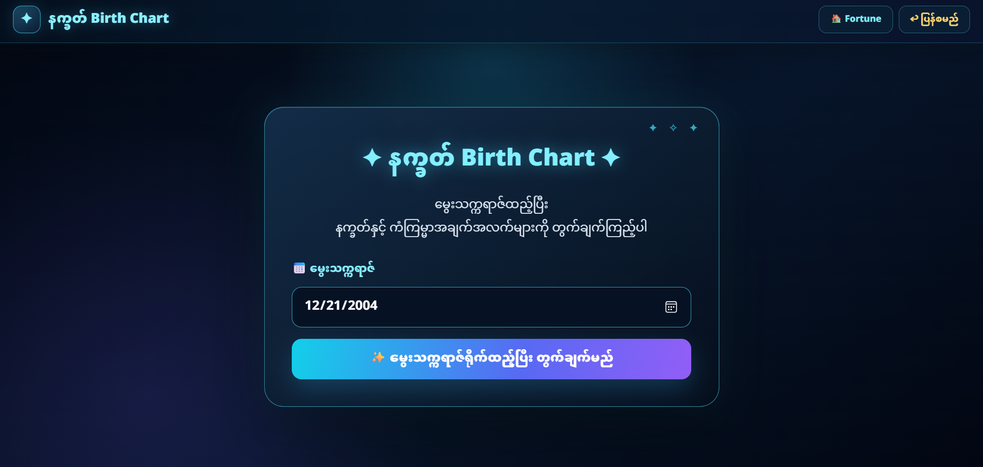
Figure 5.18 Natkat Astrology
This page allows users to enter their date of birth to calculate their astrological birth chart and destiny insights.

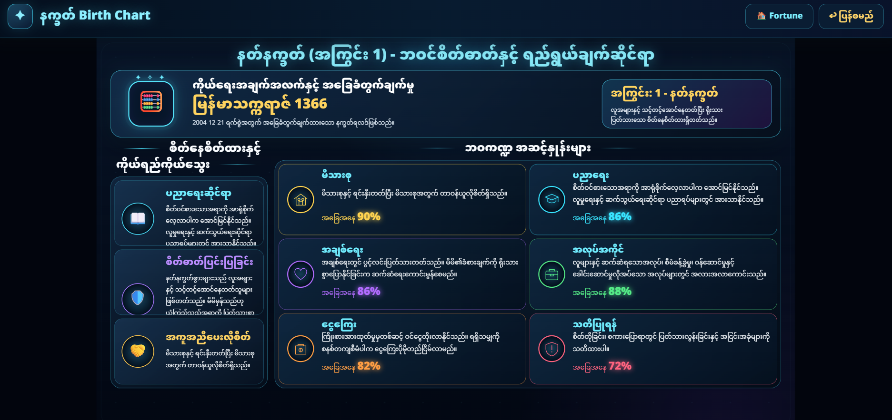
Figure 5.19 Natkat Astrology Result
This page displays the calculated astrological predictions and life aspect analysis based on the user's birth chart.

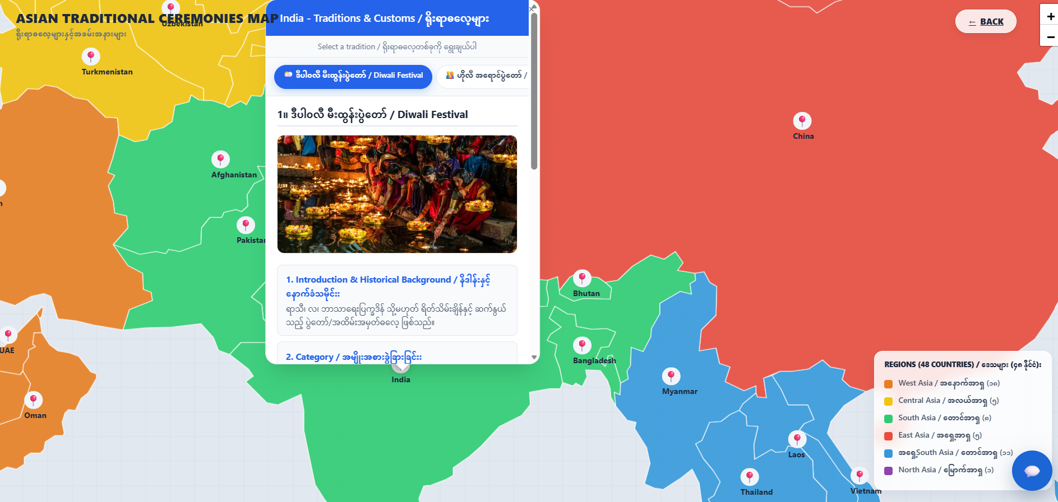
Figure 5.20 Traditional Ceremonies Result
This page displays the traditions and festivals of India.

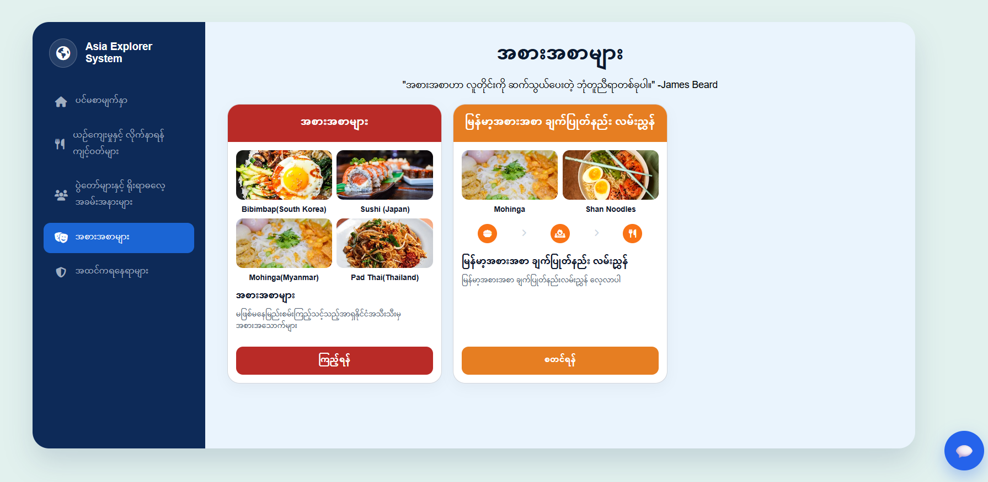
Figure 5.21 Asian Foods & Myanmar Cooking Guide
This page allows users to explore famous Asian traditional dishes and learn Myanmar recipe guides through two main sections.

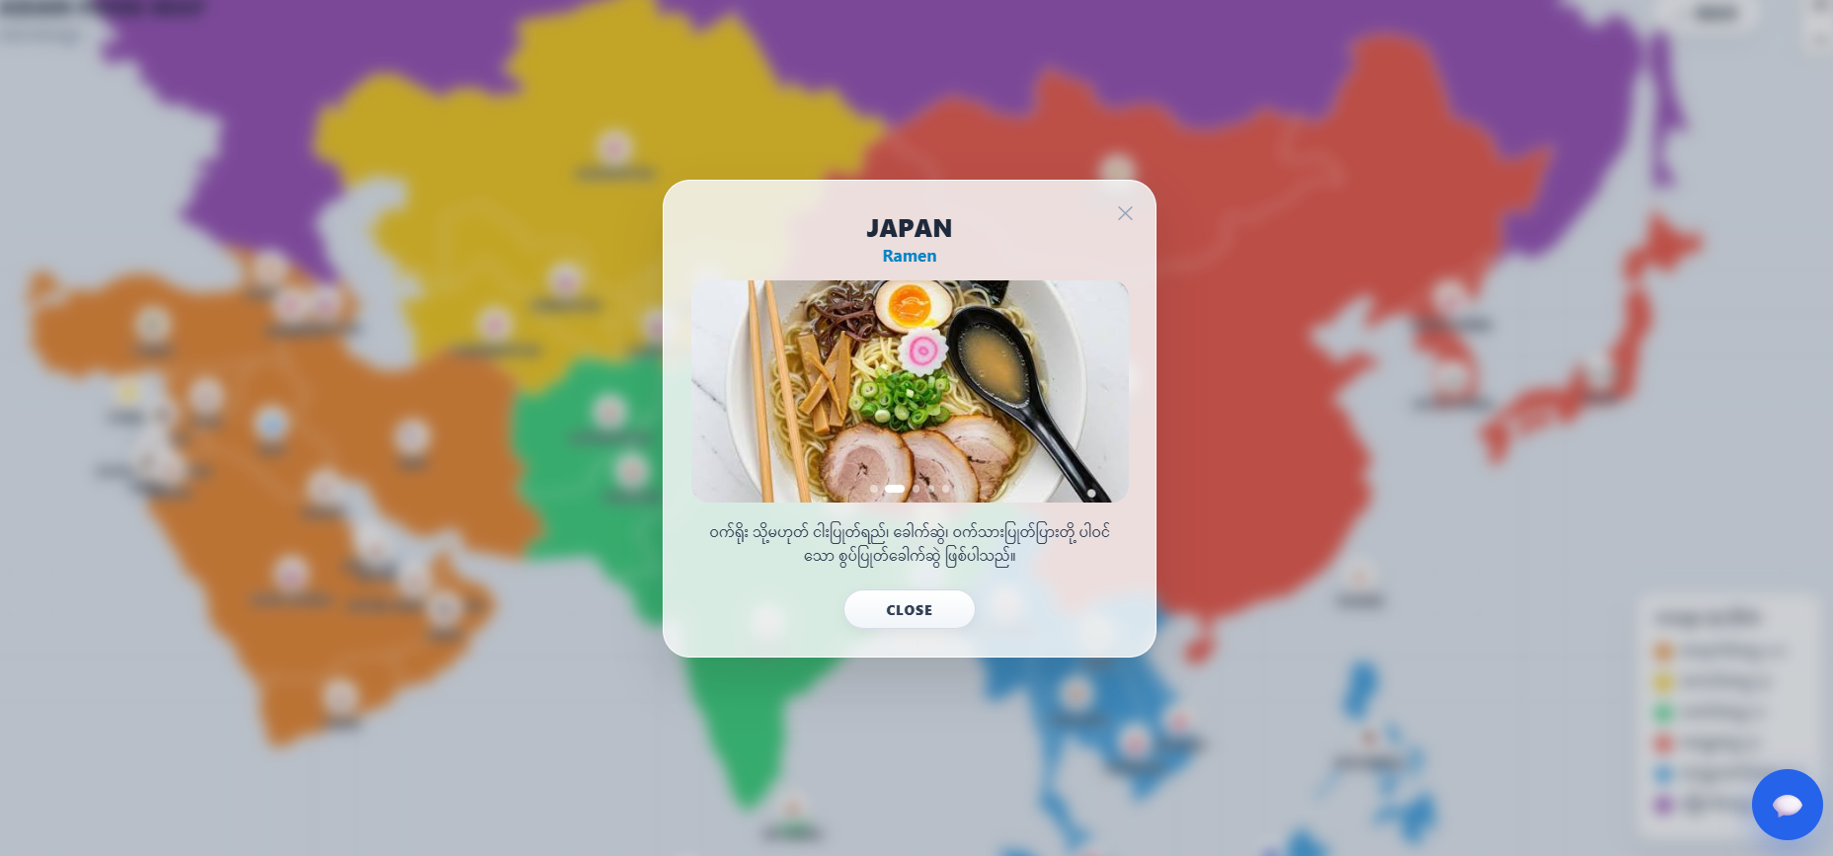
Figure 5.22 Foods Result
This page features an interactive map that clicking on a country opens a pop-up displaying its iconic dish (e.g., Japan's Ramen) along with an image and description.

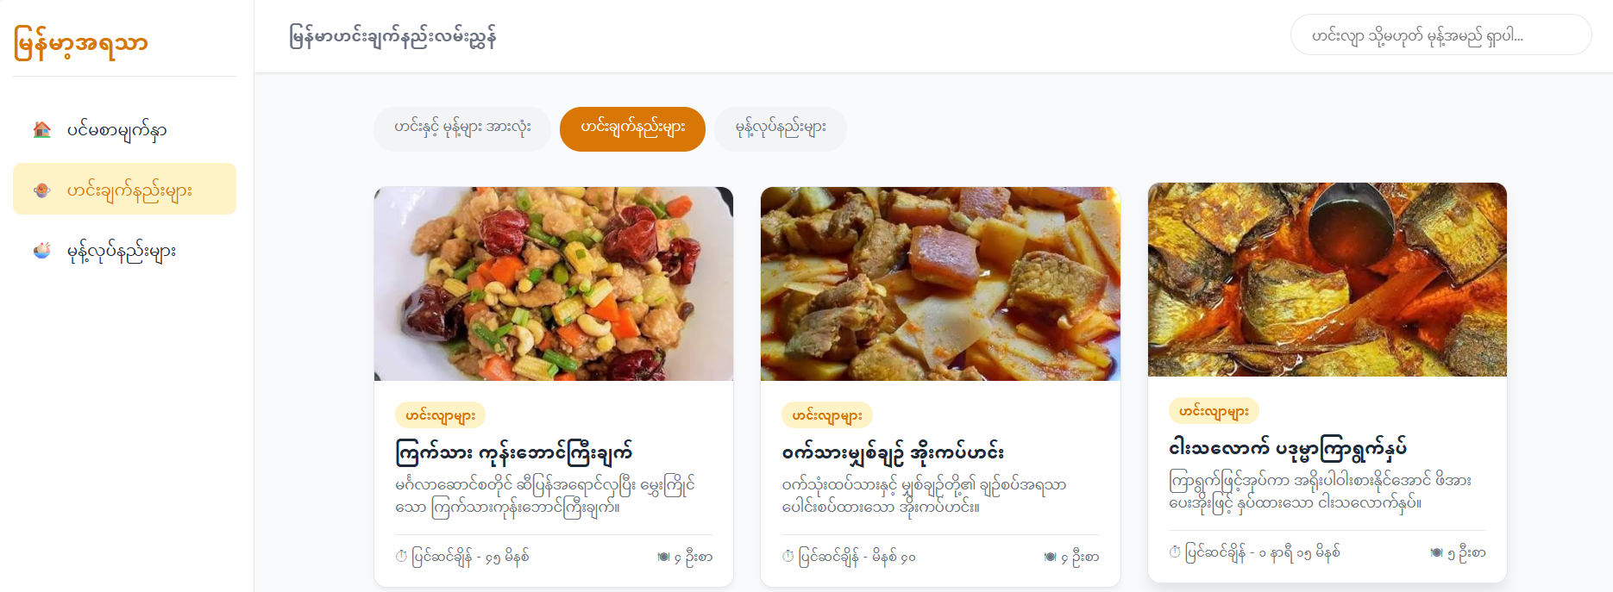
Figure 5.23 Myanmar Cooking Guide Result
This page allows users to easily search and explore traditional Myanmar recipes and snack preparation guides using category filters and a search bar.

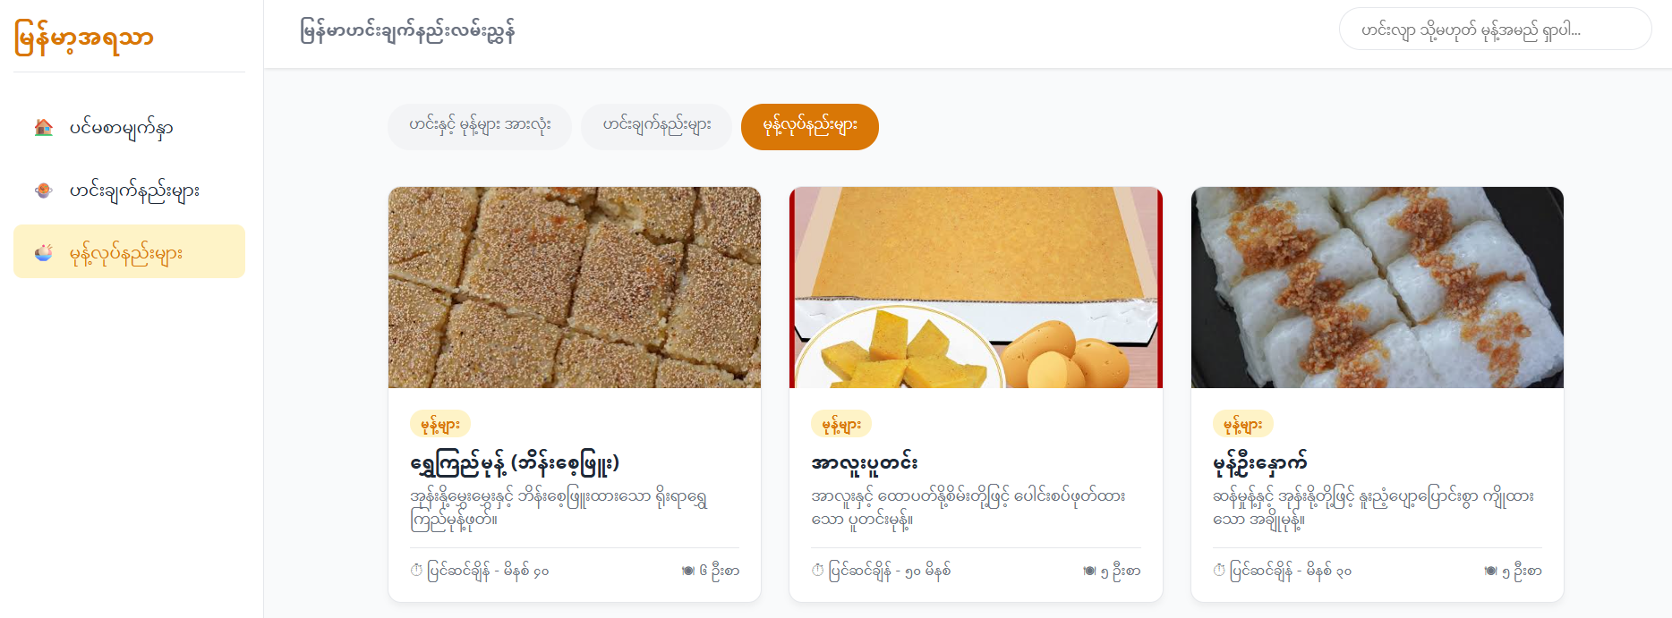
Figure 5.24 Myanmar Cooking Guide Result
This page displays a filtered list of traditional Myanmar dessert recipes, allowing users to view prep time, serving sizes, and detailed preparation steps for each item.

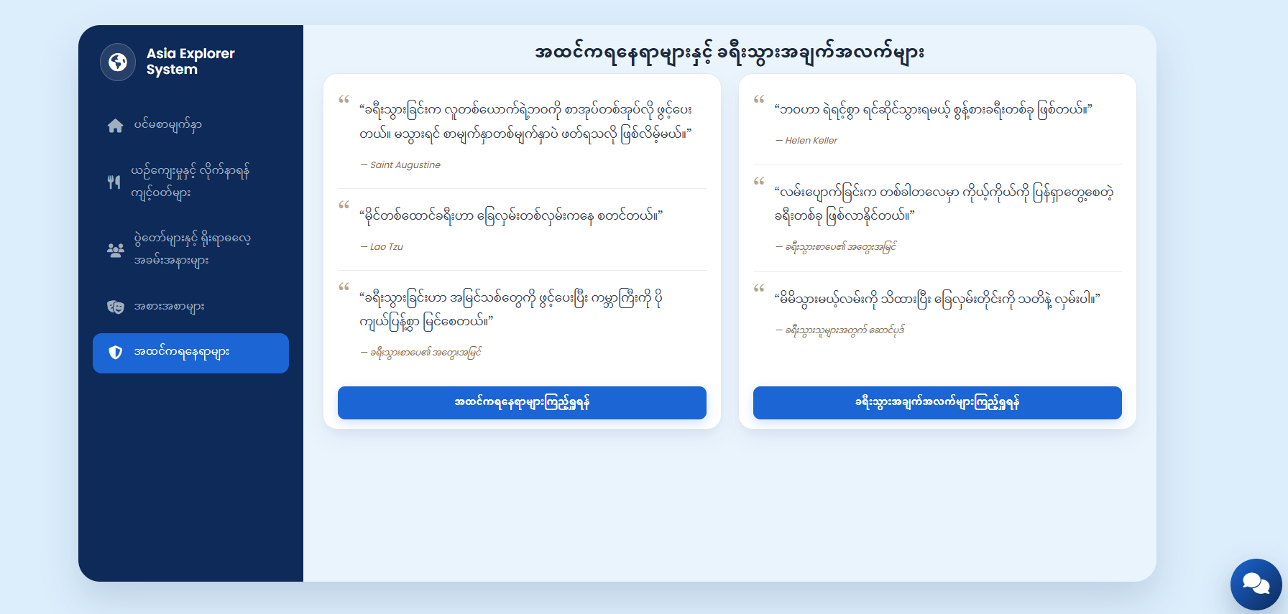
Figure 5.25 Famous landmark & Travel information
This page displays famous landmark recommendations and travel information within the Asia Explorer System.
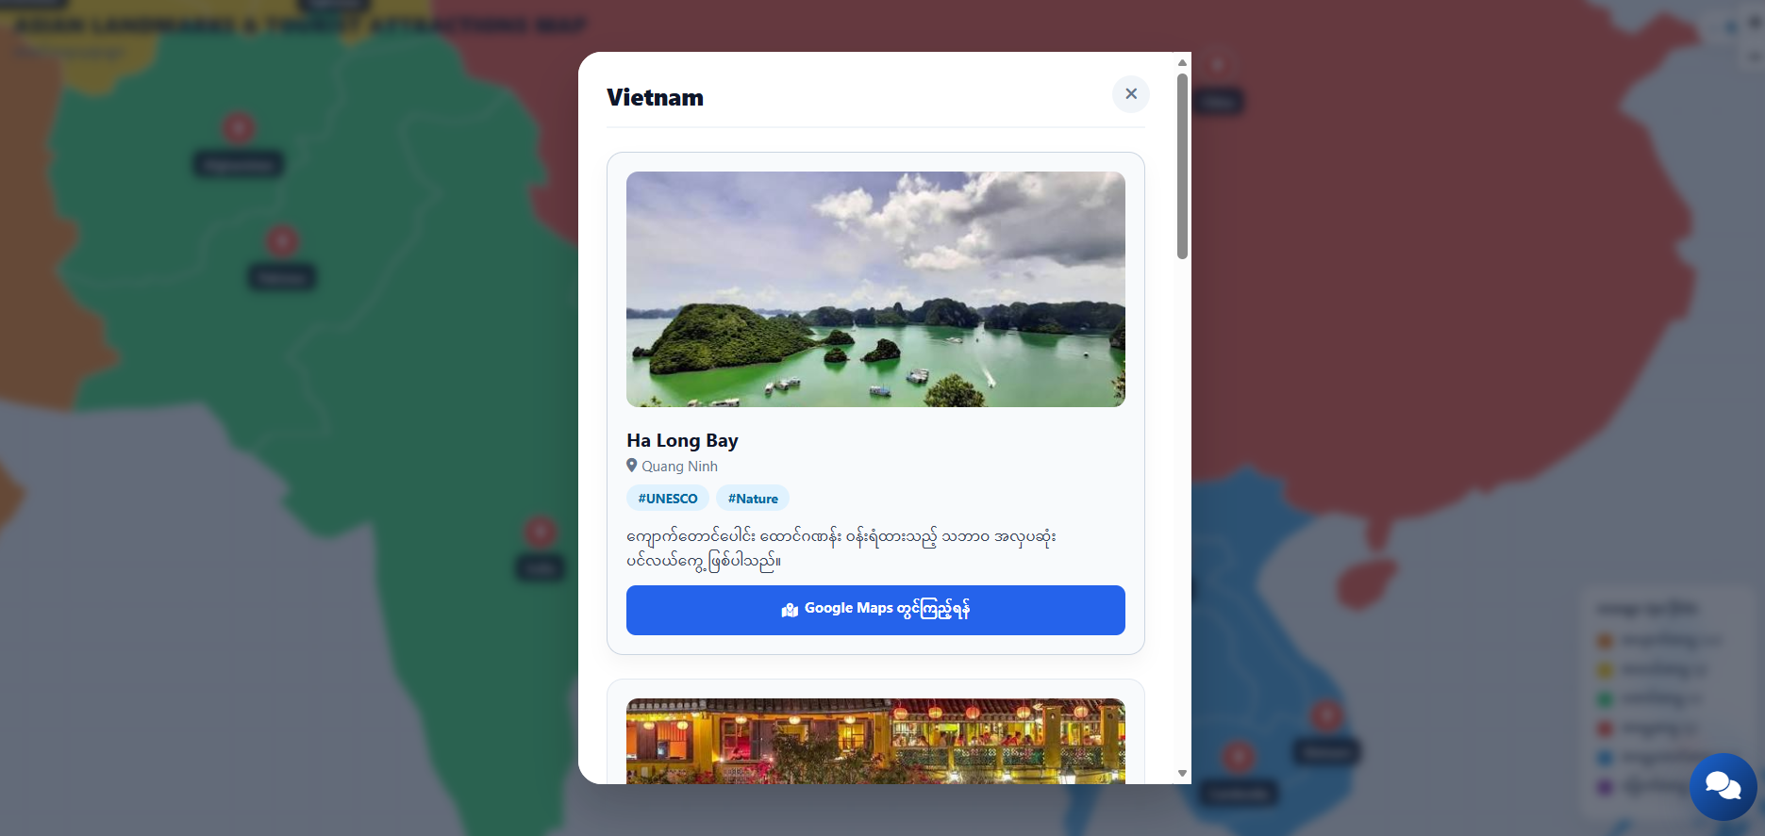
Figure 5.26 Famous landmark Result
This page appears when users select Vietnam from the interactive map within the famous places section, presenting featured attractions with location tags and direct map links.
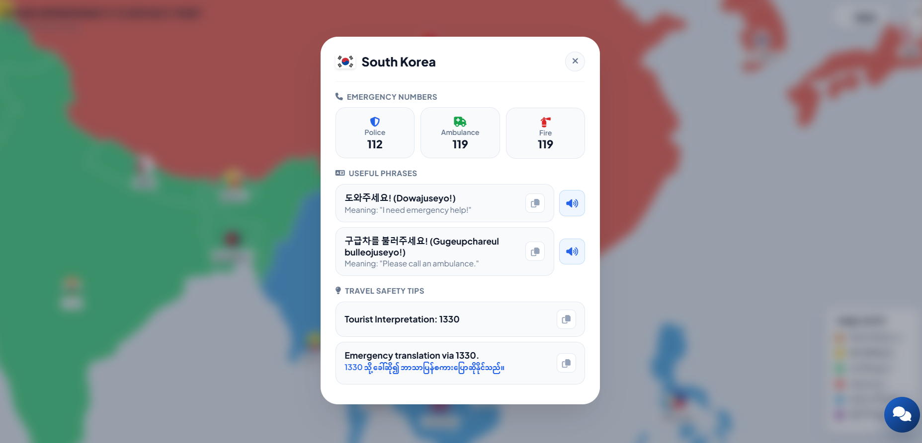
Figure 5.27 Travel information Result
This page features emergency numbers, essential Korean phrases, and the 24/7 free 1330 tourist interpretation service for travelers in distress.

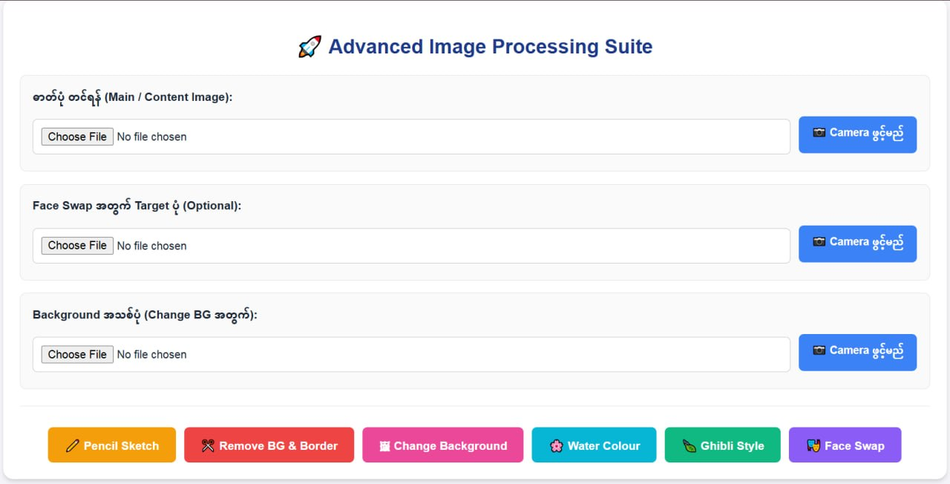
Figure 5.28 User Interface for Image Upload and Image Processing Features
When users first enter the page, they can upload the main image, an optional face-swap target image, and a new background image using either the Camera or Choose File options, and then use the six image-processing features below to transform and create customized images.
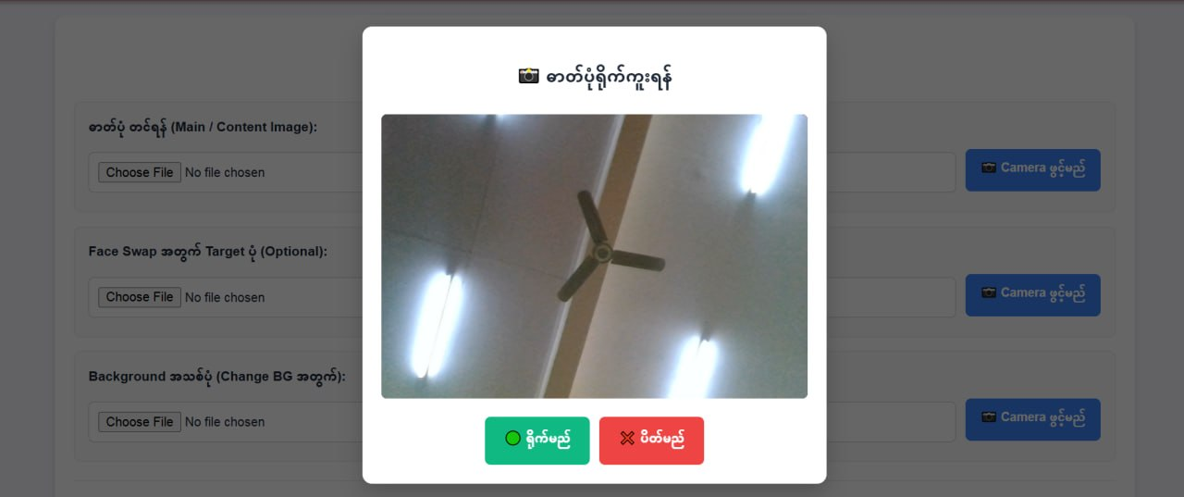
Figure 5.29 Capturing an Image Using the Camera
When the Camera button is clicked, users can capture the image they want to use for creating or editing their desired image.
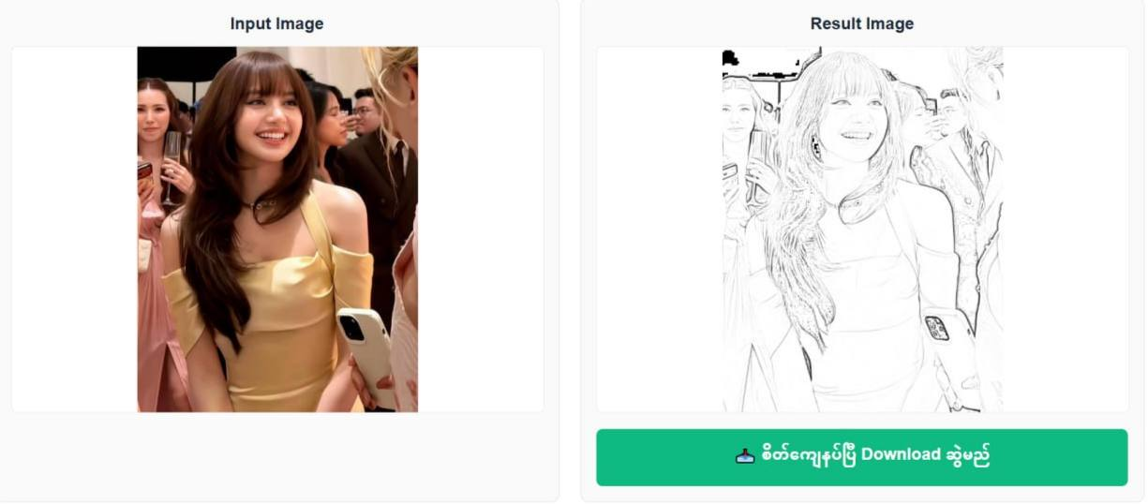
Figure 5.30 Pencil Sketch Image Processing Result
The uploaded input image is processed using the Standard Gray Sketch effect to create a simple grayscale pencil-sketch style result, which can then be downloaded.
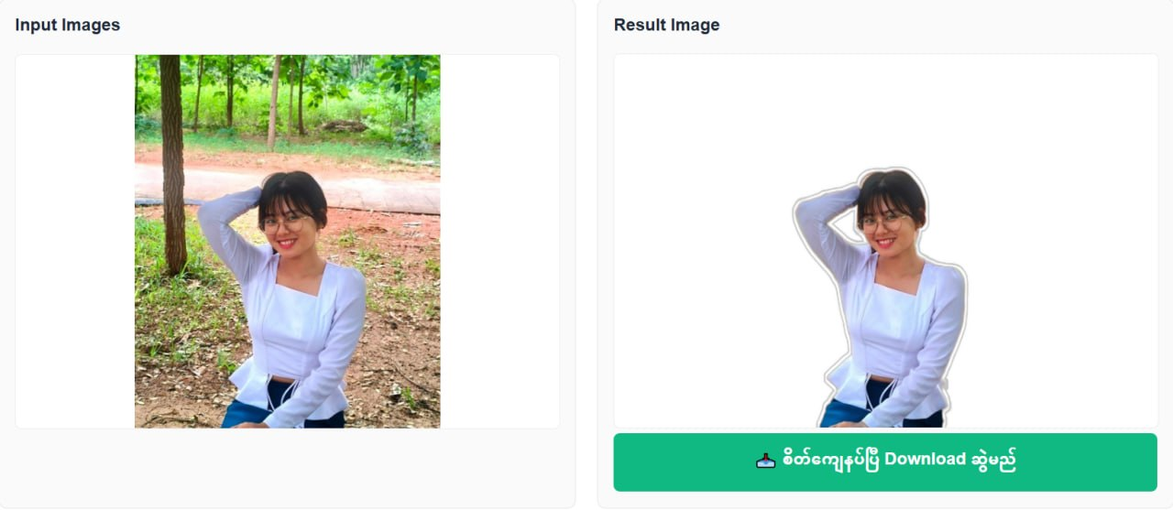
Figure 5.31 Background Removal Image Processing Result
The uploaded image is processed to remove its original background, leaving the main subject isolated with the background removed.
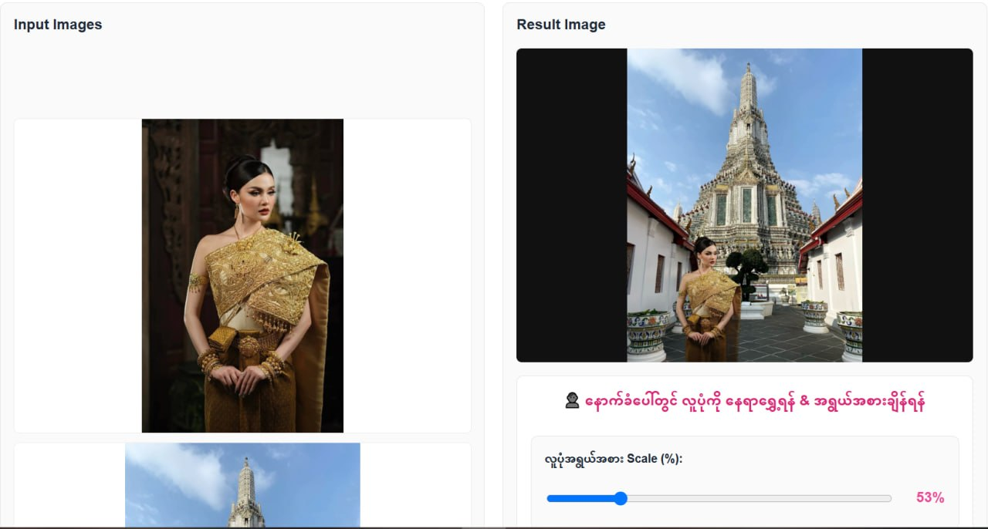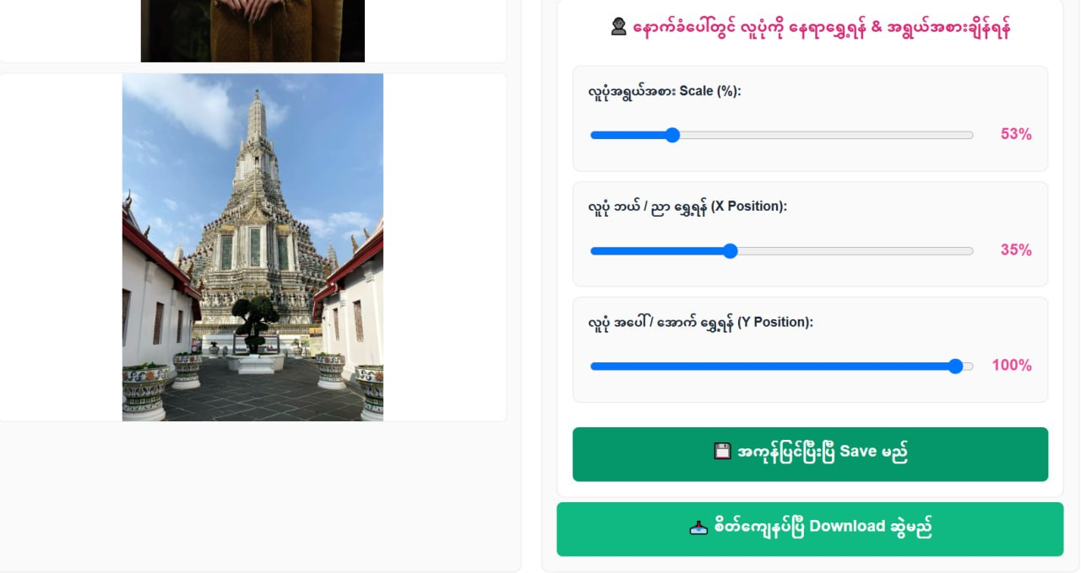
Figure 5.32 Image Background Replacement & Subject Positioning
Easily replace the image background and adjust the subject's size, horizontal, and vertical positioning to fit naturally.
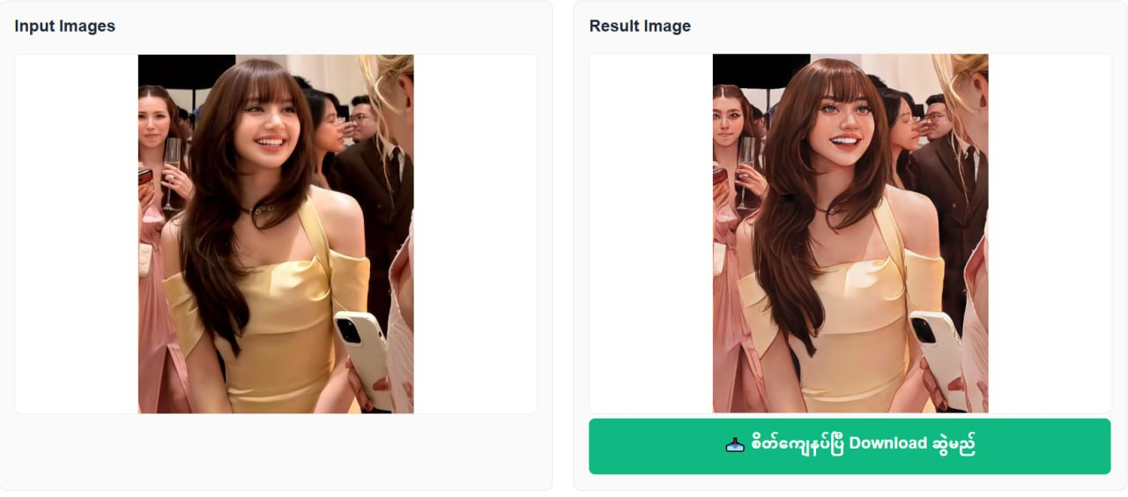
Figure 5.33 Water color Style Transformation Result
The uploaded photo has been converted into a watercolor painting.
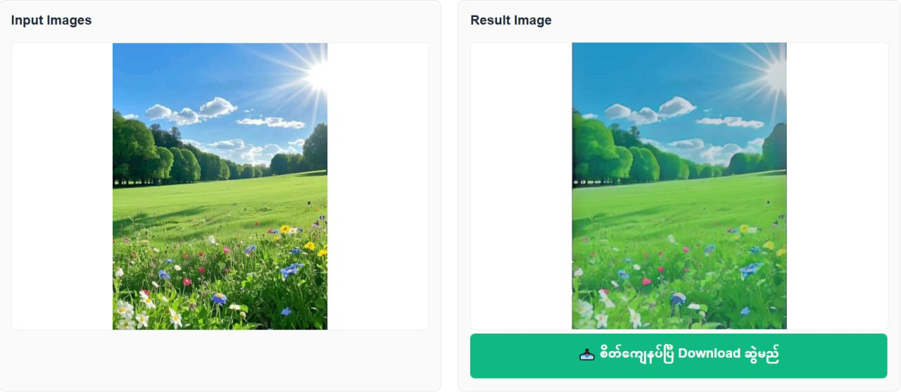
Figure 5.34 Ghibli Style Image Processing Result
It is an iconic animation style characterized by lush natural landscapes, hand-drawn painterly backgrounds, and whimsical, nostalgic storytelling that captures the quiet magic of everyday life.
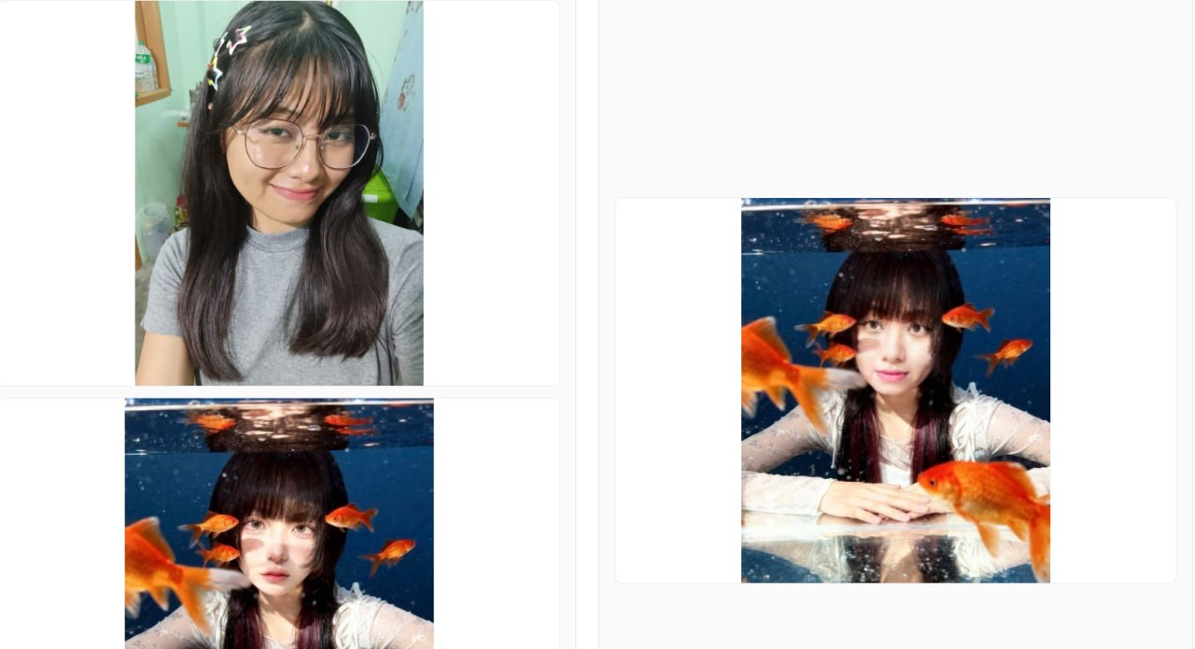
Figure 5.35 Face Swap Image Processing Result
Face Swap is a digital image processing technique that seamlessly transfers one person's facial features and expressions onto another person's portrait, creating a realistic new image while maintaining the original background and aesthetic.
5.3 Challenges Faced
Table 5.2 Challenges Faced
No | Challenge | Solution
1 | Asia Map & Country Selection and Regional Data Management  The necessity to systematically categorize and display regional information (Culture, Festivals, Foods, Landmarks) for Asian countries, and accurately present relevant data based on user selection. | Precise routing logic was implemented within the Flask Backend (app.py), seamlessly linking country-specific data and images stored systematically in a structured directory (Global/images/).
2 | Integrating Image Processing and Style Transformations  Executing dynamic image features—such as Pencil Sketch, Water Color, Ghibli Style, Background Change, and Face/Image Processing—within the system while ensuring fast output generation without sacrificing image quality. | Image resizing, filter applications, and preprocessing stages were optimized using Python and OpenCV to build a robust and performant execution pipeline.
3 | Integrating Chinese and Myanmar Divination / Fortune Telling  Building a system module that allows users to easily explore traditional cultural divination and fortune-telling information for China and Myanmar. | Developed a clear, user-friendly interface integrated directly into the web application, enabling users to access Chinese and Myanmar divination insights effortlessly.
4 | Integrating Chatbot and Interactive Features  Providing an interactive Chatbot and integrating key features smoothly into the Web UI to assist users with inquiries and guidance. | Connected Frontend templates with the Python Flask Backend to process user requests instantly without latency, delivering seamless real-time responses.
5 | Large-Scale Image Uploads and Storage Management  Managing high-volume and large file uploads from users to prevent server memory bottlenecks and enforce proper file format validation. | Implemented server-side validation rules for strict file size limits and file type checks to maintain system stability and resource control.
6 | User Session and State Management  Accurately tracking each user's selected country, applied filters, and Chatbot interaction history without cross-session data leaks or conflicts. | Built secure session state tracking using Flask Session Management to safely and smoothly record individual user activities and contextual data.

CHAPTER 6
CONCLUSION
The Asia Explorer System successfully delivers a unified, feature-rich web platform that bridges cultural education, specialized astrological computing, and computer vision technologies. By consolidating comprehensive regional knowledge across 48 Asian nations—including culture, etiquette, festivals, foods, and landmarks—the system serves as an interactive educational repository.
The integration of the 6-stage image processing pipeline demonstrates the effective application of OpenCV and Pillow, enabling dynamic visual transformations such as Pencil Sketch, Water Color, Ghibli Style, Background Removal/Replacement, and Face Swapping directly through a web-based interface. Furthermore, the platform offers localized astrological computation modules for Myanmar and China, seamlessly supported by an interactive chatbot for real-time user assistance.
From a software engineering perspective, the system achieves modularity, high maintainability, and loose coupling through the implementation of established architectural and design patterns, specifically Model-View-Controller (MVC), Factory Pattern, and Strategy Pattern. Supported by a robust Python Flask backend, structured directory routing, and strict session and file management rules, the Asia Explorer System meets all core design objectives, providing a performant, scalable, and secure solution for multi-domain digital interaction.
6.1 Future Work
While the system fulfills all initial project requirements, several avenues remain open for future development and scaling:
• Expansion of Astrological Modules: Extend specialized calendar and astrology calculation engines to cover additional Asian nations, such as Thai Solar and Vedic Astrology systems.
• AI Model Integration: Upgrade rule-based filters and classic image processing methods with deep-learning generative models (e.g., Stable Diffusion or GANs) for enhanced artistic transformations.
• Mobile Application Development: Adapt the responsive web interface into native mobile applications (iOS/Android) to reach a broader user base.
• Multi-Language Support: Incorporate localization (i18n) to support native languages across Asian regions, enhancing accessibility for international users.
6.2 Lessons Learned
Object-Oriented Design and Development
Through this project, we gained practical experience in applying Object-Oriented Design principles such as abstraction, encapsulation, inheritance, and polymorphism. We learned how to transform system requirements into UML diagrams, including Use Case Diagrams, Class Diagrams, Sequence Diagrams, and Data Flow Diagrams.
Designing these diagrams helped us clearly understand how different components interact within the system. We also applied SOLID principles (SRP, OCP, LSP, ISP, DIP) to ensure modularity and maintainability. Writing unit tests and performing debugging allowed us to detect errors early and improve system reliability.
This experience strengthened our ability to design scalable and maintainable software systems.
Advances Database Systems
From the database perspective, we learned how to design normalized relational tables such as Student, Admin, Project, Department, and Approval records to reduce redundancy and maintain consistency.
We implemented complex SQL queries to retrieve project details, filter approved projects, and generate reports efficiently. Handling database transactions ensured that operations such as project submission and approval were executed safely. For example, when a project is submitted, multiple tables are updated. Managing these operations within a transaction ensures that either all changes are committed or none in case of failure.
We also understood the importance of indexing, foreign key constraints, and data validation to maintain data integrity and optimize performance.

REFERENCES
[1] Rajib Mall,,, “Fundamental of Software Engineering”, 4th Edition, 2014
[2] Brahma Dathann ad Sarnath Ramnath, “Object-Oriented Analysis, Design and Implementation”, An Integrated Approach, Second Edition, 2015, UTiCS, Springer.
[3] Fundamentals of Software Engineering
[4] Software Engineering (Ian Sommerville)
[5] Software Engineering (Roger S. Pressman, Bruce R. Maxim)
[6] Practical Object-Oriented Design With UML (Mark Priestley)
[7] Object-Oriented Analysis, Design and Implementation (Brahma Dathan, Sarnath Ramnath)
[8] Database system concepts, 7th edition https://db-book.com/

